TraceFP

User Guide

**User Guide**

* Introduction
* Basic interface
  + How to open a floor plan file (.fp)
  + How to open a wall sample file (.dq)
  + How to save modified floor plan file
  + Clear all data on screen
* Graphics rendering
  + Display wall samples, control points, and rooms
  + Refresh
* Basic floor plan manipulation
  + Basic point manipulation
    - Add point(s) to the floor plan
    - Merge and relocate a set of points on the floor plan
    - Remove point(s) from the floor plan
  + Basic room manipulation
    - Construct triangle(s) for a room
    - Remove triangle(s) from a room
    - Construct convex polygon(s) for a room
  + Undo / Redo
* Advanced floor plan manipulation
  + Points
    - Merge multiple points into one point
    - Clustering points
  + Lines
    - Align points to a line
    - Align points to a pair of orthogonal lines
  + Rooms
    - Add a point to a room and extend room borders
    - Split a triangle into multiple triangle along a point
    - Reduce number of triangles without changing coverage of rooms
  + Axis alignment
    - Align all lines to direction
    - Adjusting tolerance degree

**Introduction**

TraceFP is an application to manipulate floor plan files.

Floor plan files (.fp) uses triangles as basic building blocks of rooms. Each room is consisted of one or more triangles. Each triangle is assigned a room id. Different triangle can have the same room id, so that they can together represent an area that the particular room occupies. Each triangle must have its points based on control points, which is displayed as pink points on the screen.

The application also supports the use of wall samples files (.dq). Wall samples are displayed as blue points on the screen, as opposed to control points, which are pink.

**Basic interface**

**How to open a floor plan file (.fp)**

Click on the “open fp file” button. Select the corresponding .fp format floor plan file. It might take a while for the floor plan file to be read and rendered.

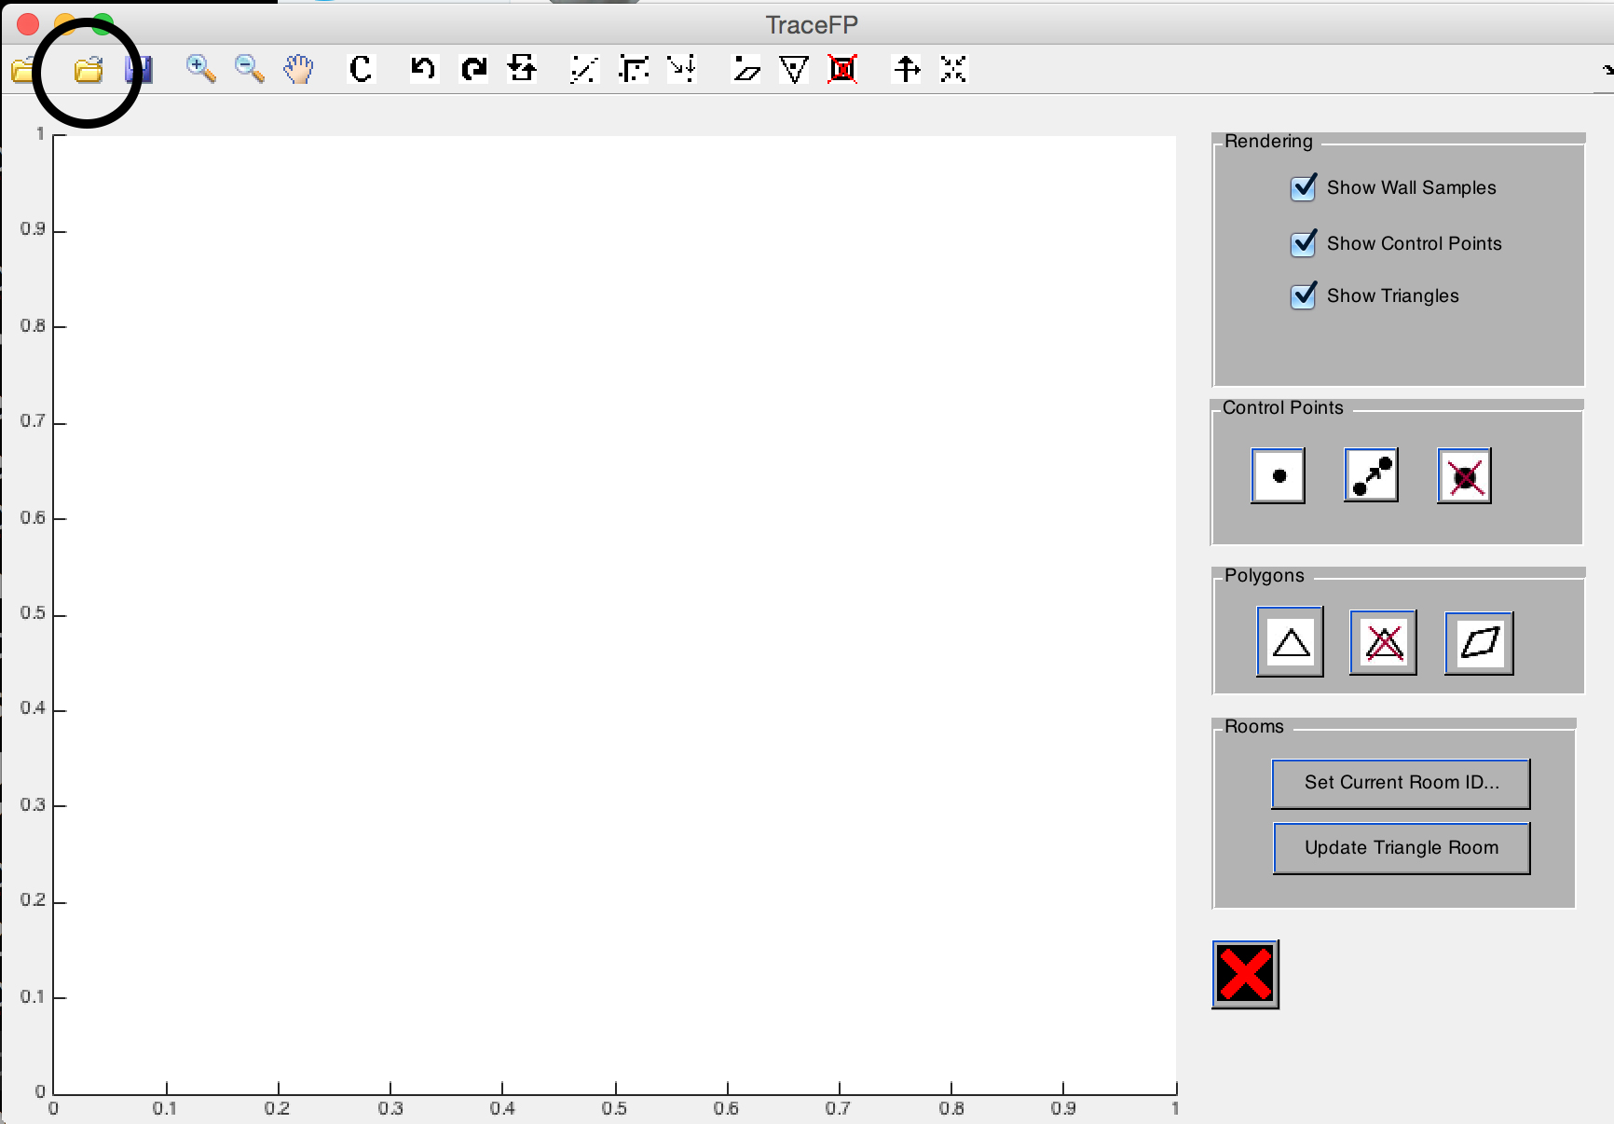

**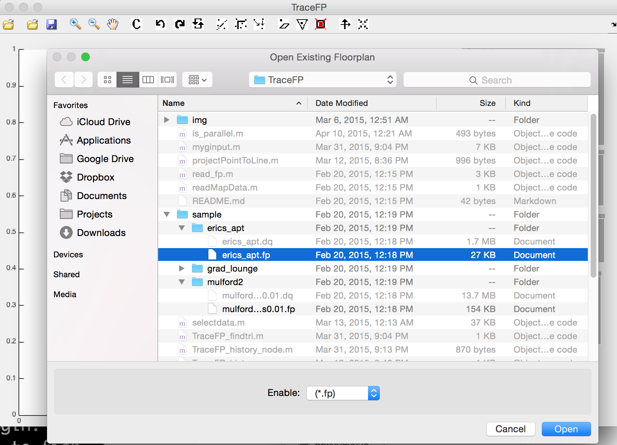****How to open a wall sample file (.dq)**

Click on the “open dq file” button. Select the corresponding .dq format wall sample file. It might take a while for the wall sample file to be read and rendered.

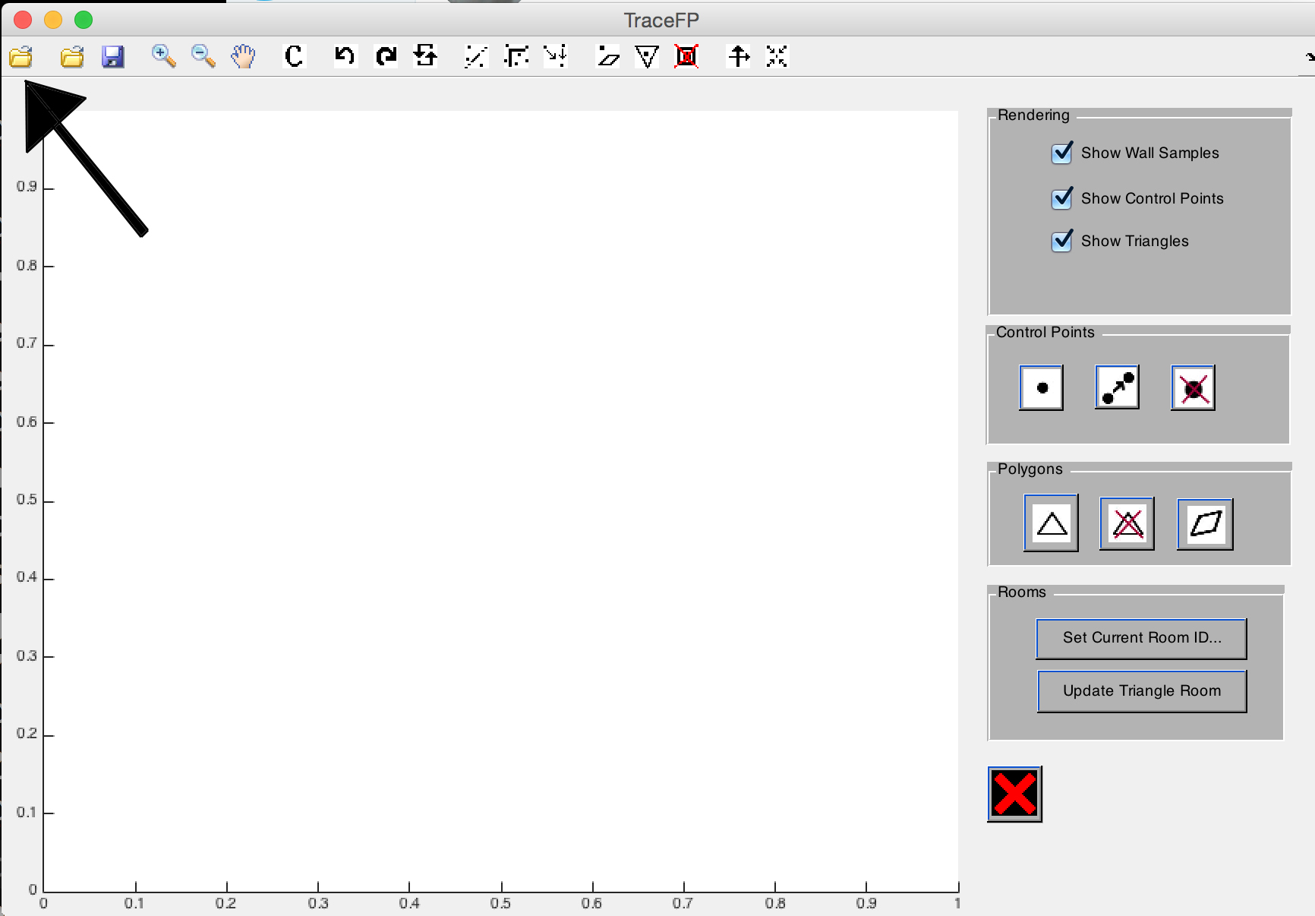

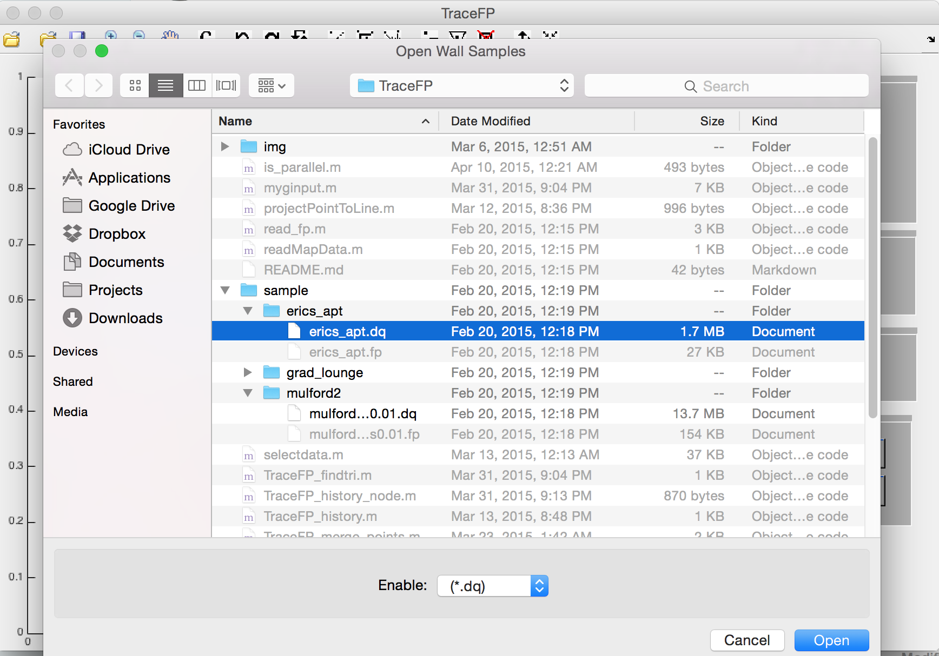

**How to save modified floor plan file**

Click on the “save fp file” button. If the file is newly created, the application will prompt you for path to create the file. Otherwise, the file is automatically saved to the original opened file.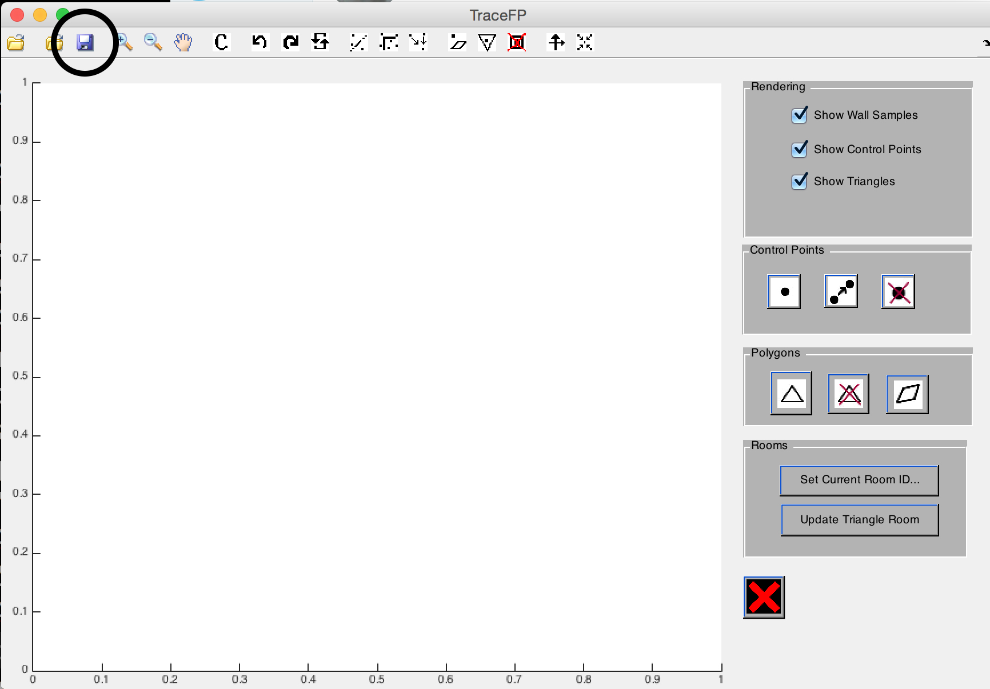

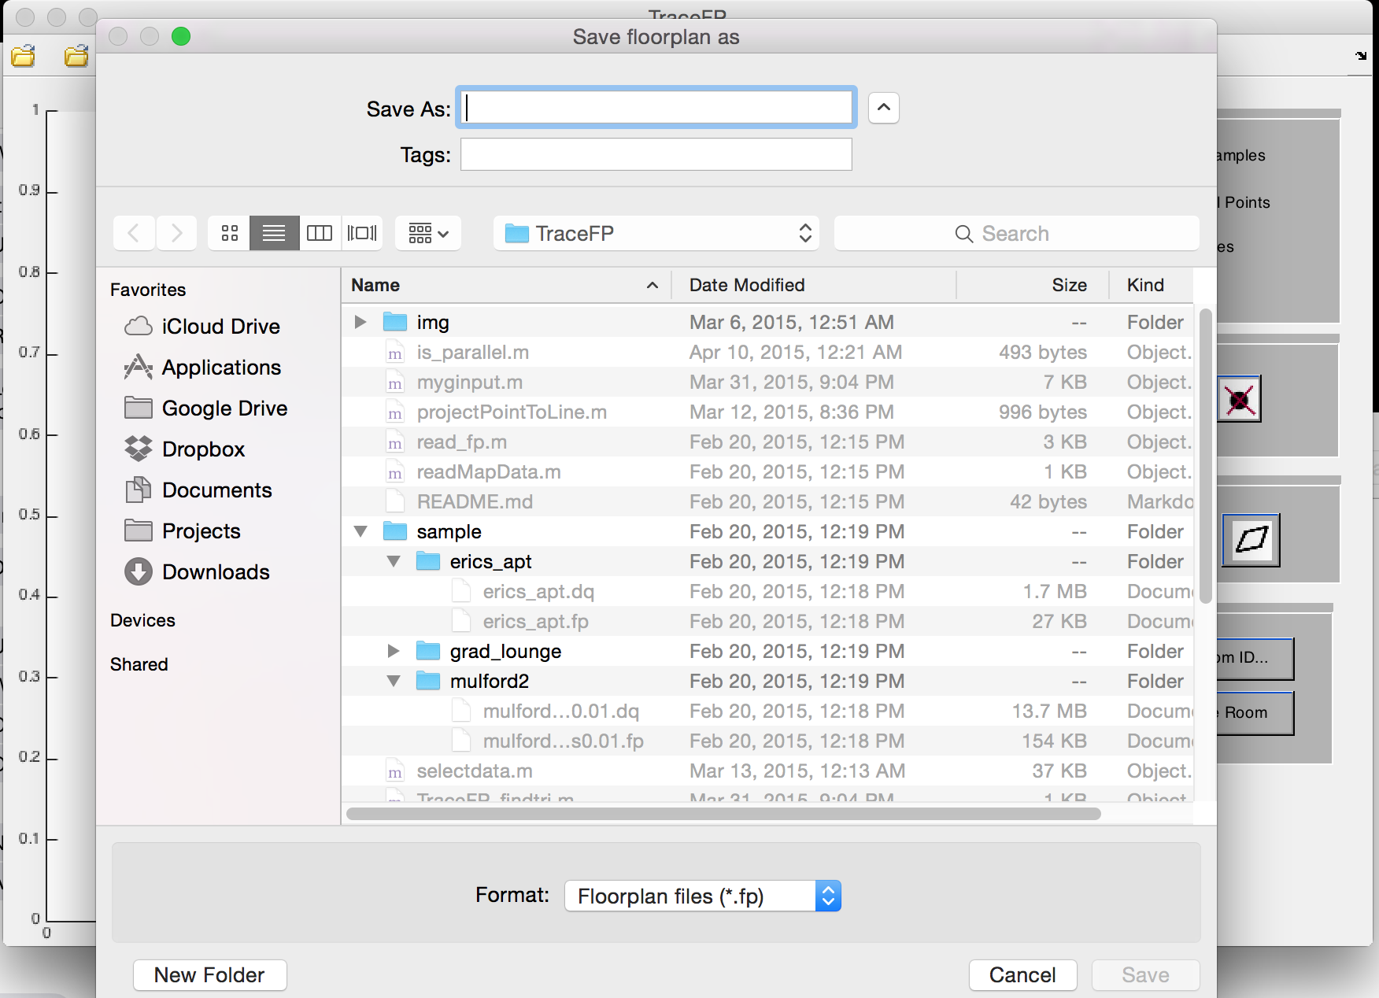

**Clear all data on screen**

If the “clear” button (as indicated below) is clicked, everything currently loaded on the screen will be cleared, including triangles, control points and wall samples.

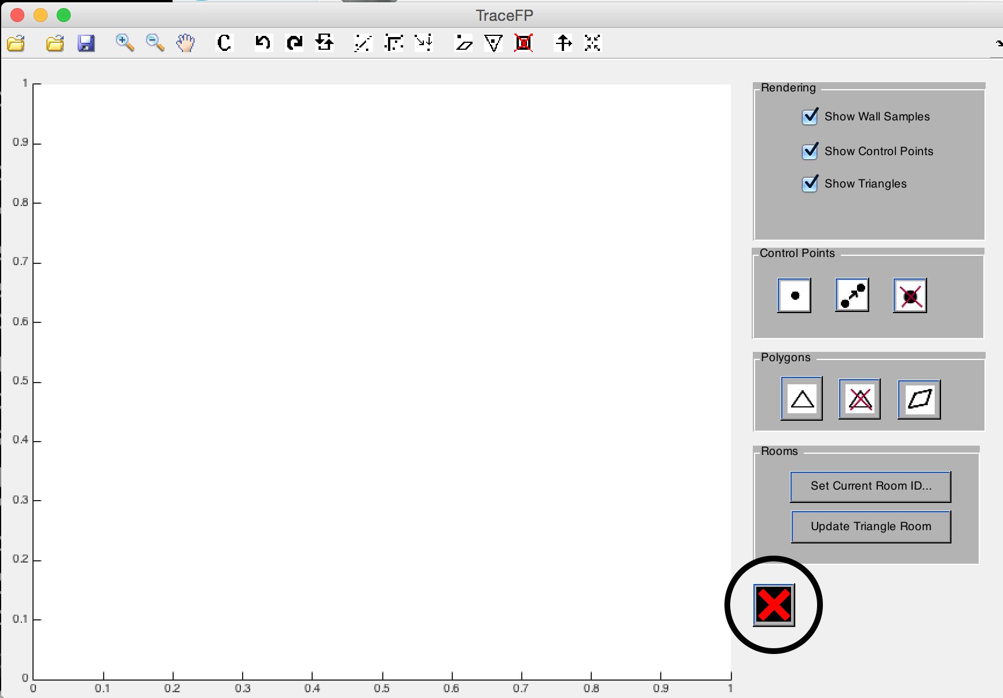

**Graphics rendering**

**Display wall samples, control points, and rooms**

The three checkboxes on the top right of the screen control whether to display wall samples / control points / triangles.

Unchecking “Show Wall Samples” checkbox (as indicated below) will hide all wall samples from the screen. However, the wall samples are still loaded so you do not have to reload wall sample file to show them again. Simply check the box again and hidden wall samples will appear on the screen. If the wall samples did not appear as expected, refresh the screen.

The other two checkboxes (as indicated below) work in exactly the same way but they hide control points and triangles respectively.

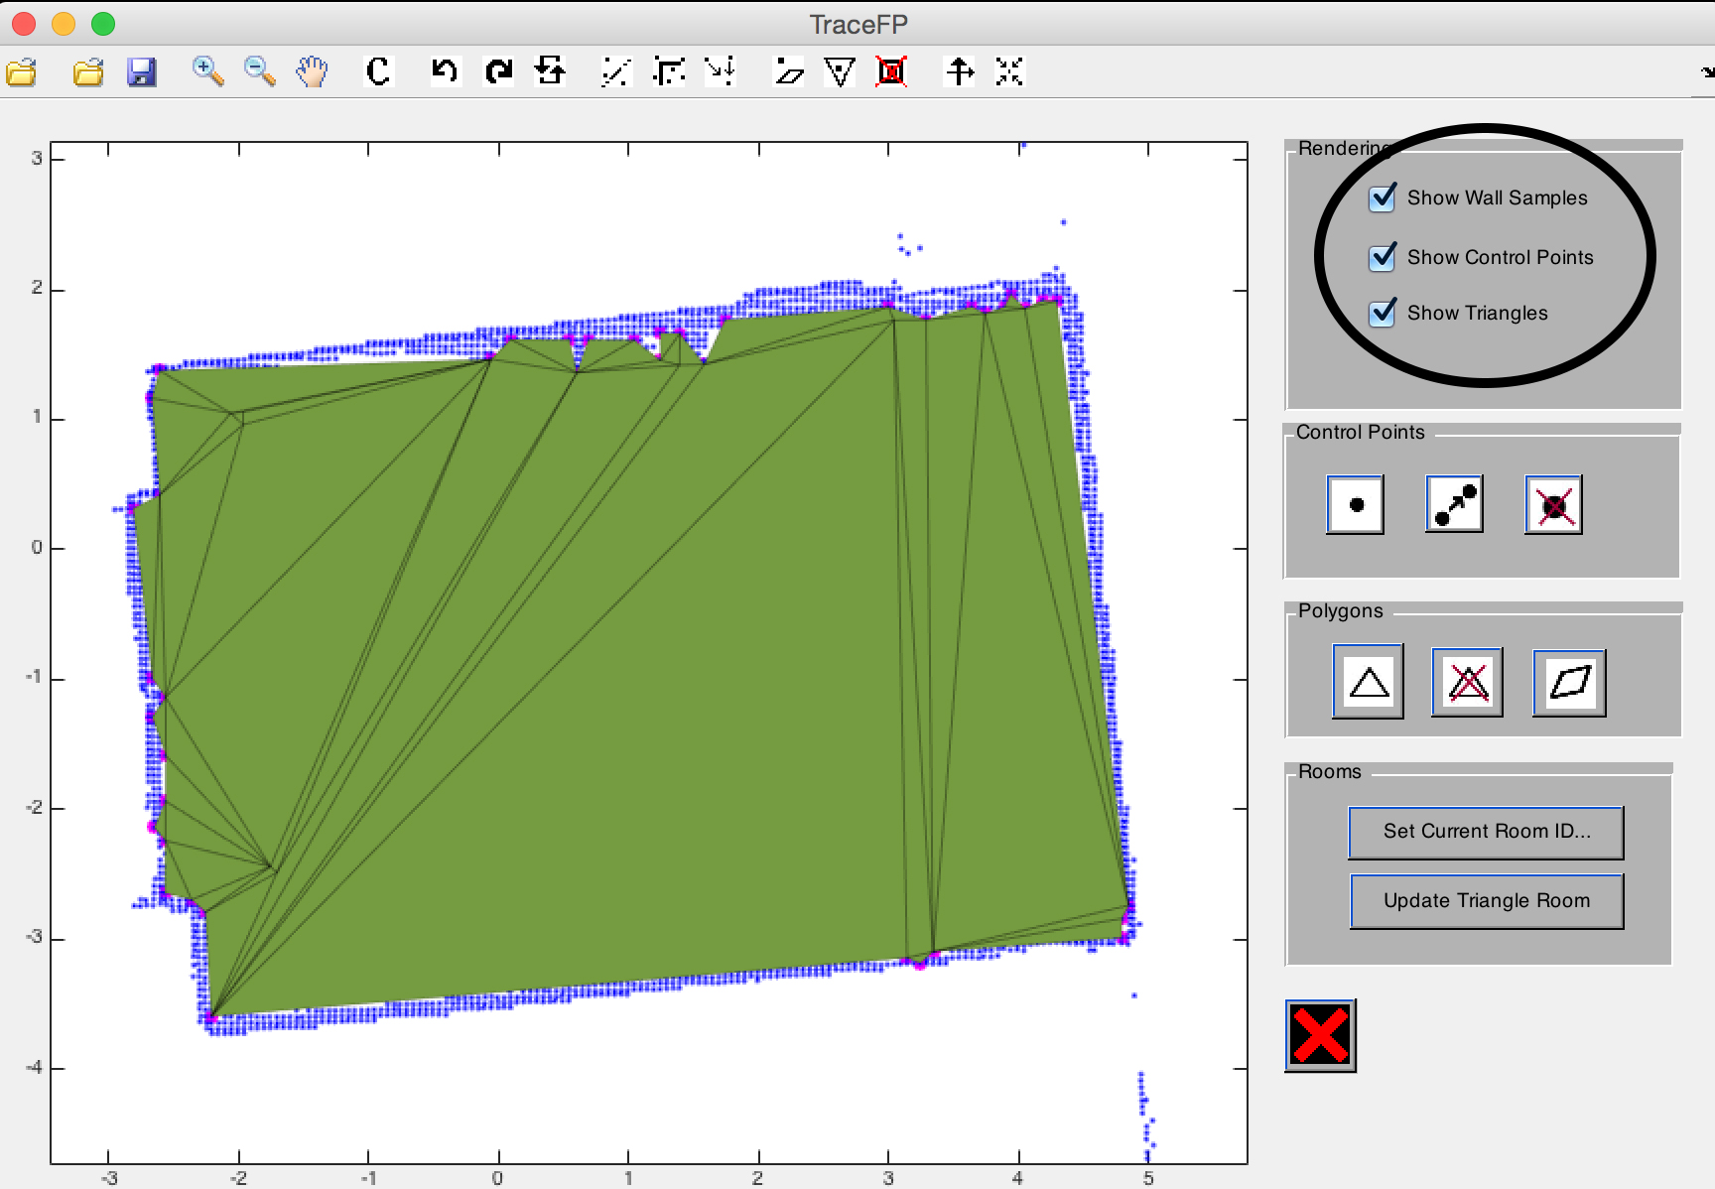

**Refresh**

The refresh button (as indicated below), is used to refresh the screen. Clicking the button will cause all graphics, including control points, wall samples and triangles to be re-rendered.

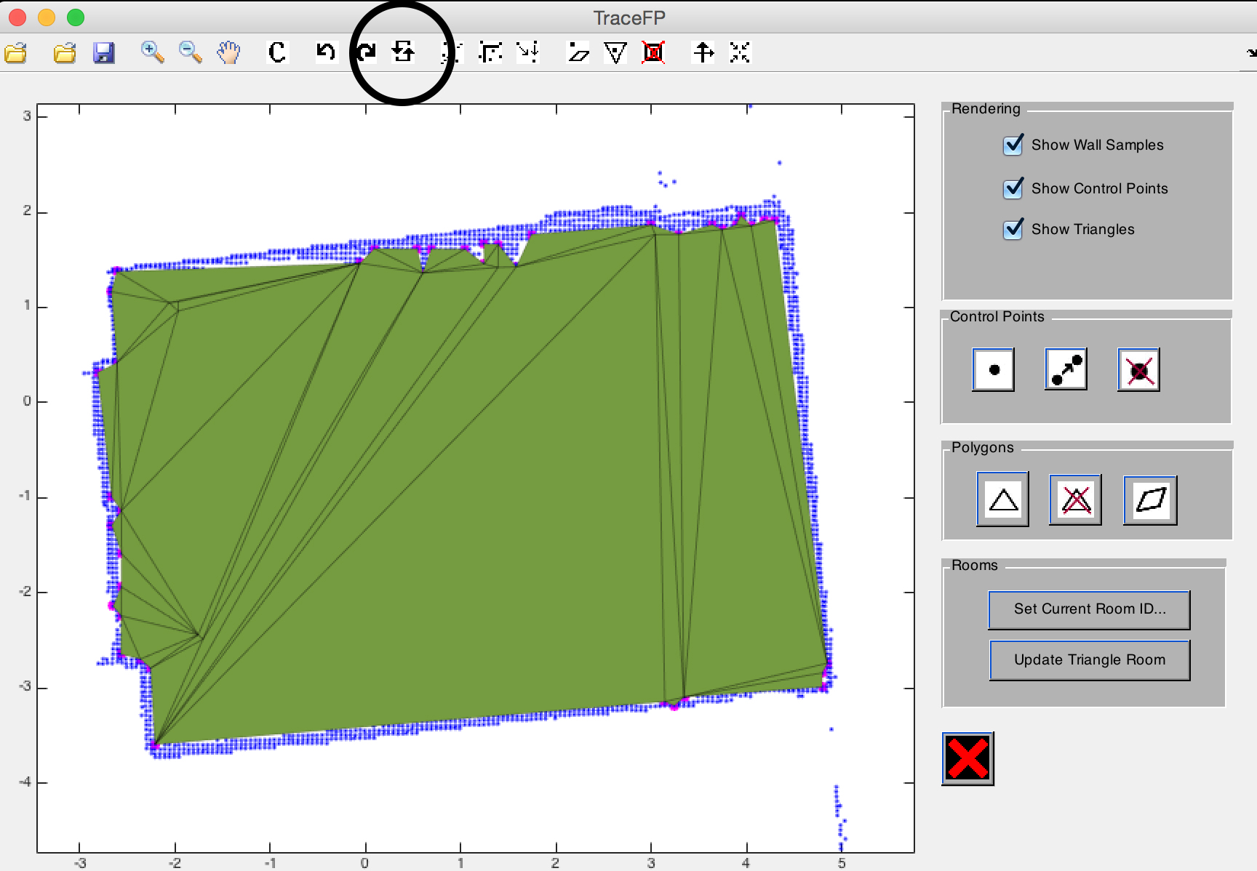

**Basic floor plan manipulation**

**Basic point manipulation**

**Add point(s) to the floor plan**

To add points to the floor plan, click on “add points” button (as indicated below) then click on points where you want to add a point at. After adding all the points, right click on the floor plan to stop adding points.

User can right click anywhere on floor plan to exit this functionality anytime.

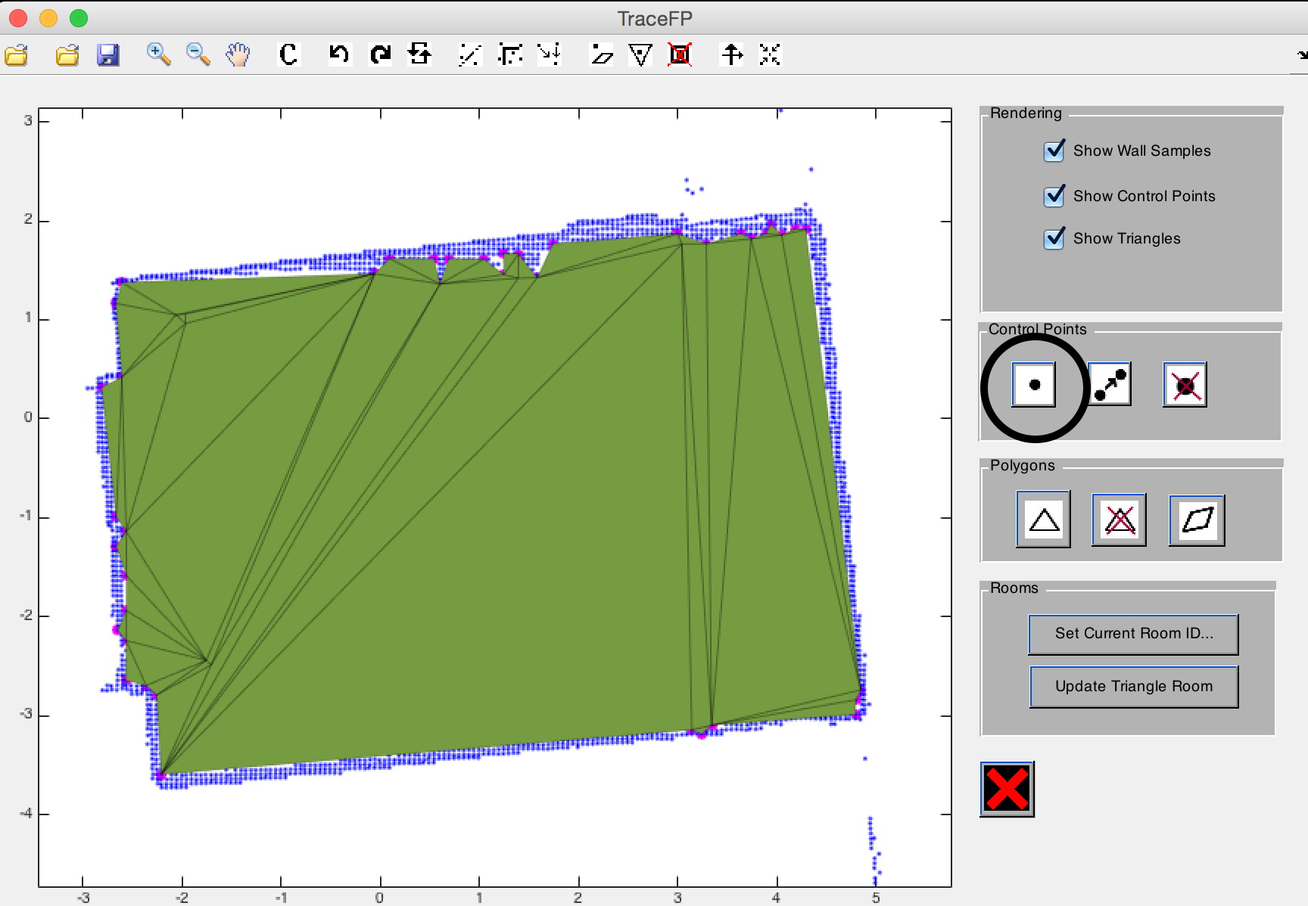

**Merge and relocate a set of points on the floor plan**

To move a point on the floor plan to another location, click on the “merge and relocate” button (as indicated below). First, select a point to relocate, and then select a new position to relocate this point to.

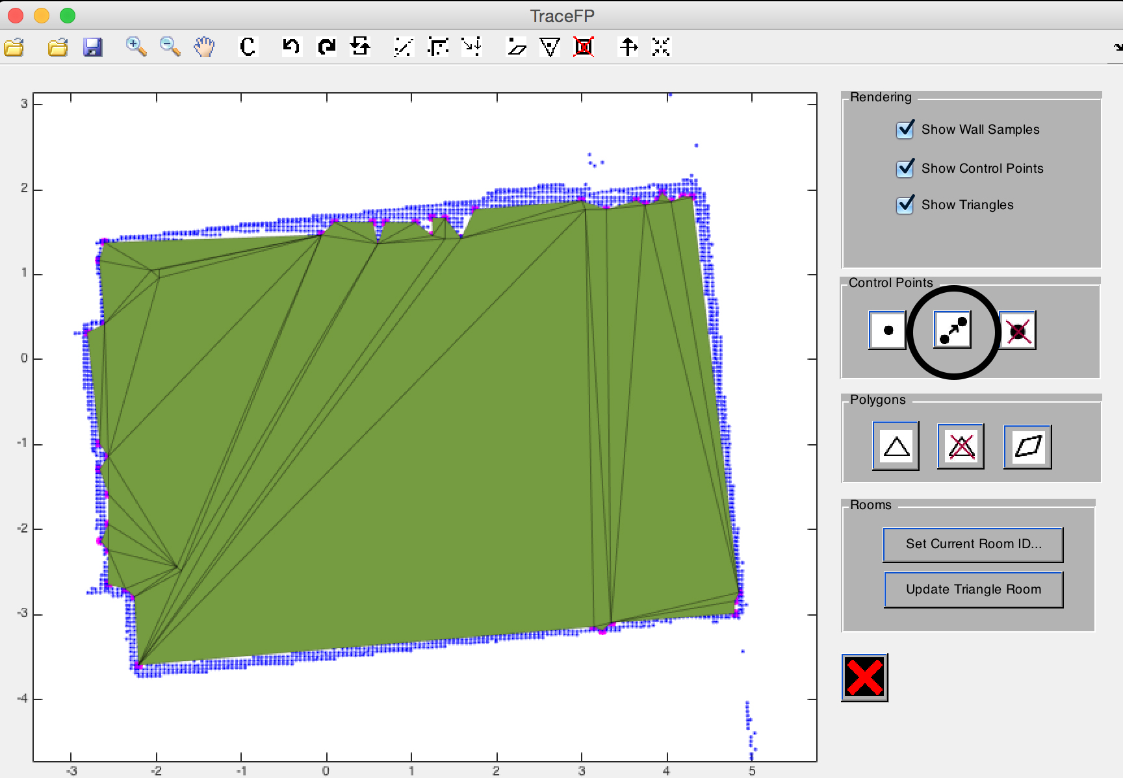

This button can also move a set of points to the same location, to select a set of points, click and drag the lasso tool over the floor plan. Selected points will be displayed as red points. Points will be first merged into one, and then moved to the indicated location. User can right click anywhere on floor plan to exit this functionality anytime.

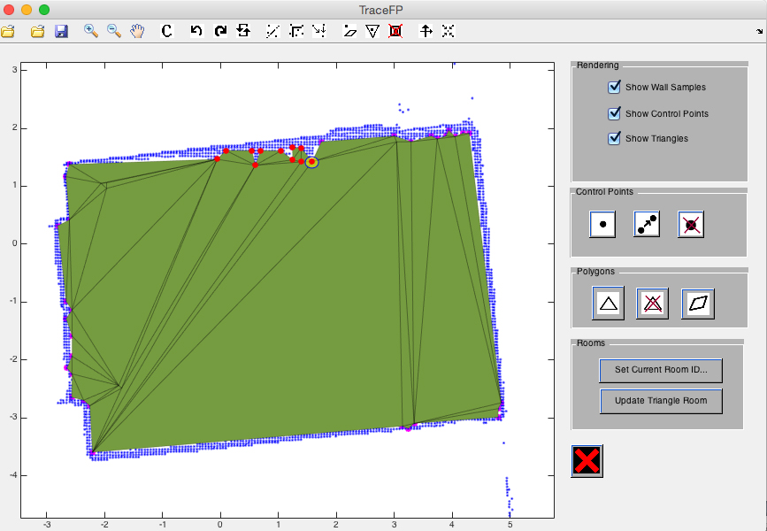

**Remove point(s) from the floor plan**

To remove one or more points from the floor plan, click on the “remove point” button (as indicated below). Then, click and drag over any number of points to remove. User can repeatedly click and drag to remove points in different locations of the floor plan to remove multiple sets of points. Any triangle associated with removed points will also be removed.

User can right click anywhere on floor plan to exit this functionality anytime.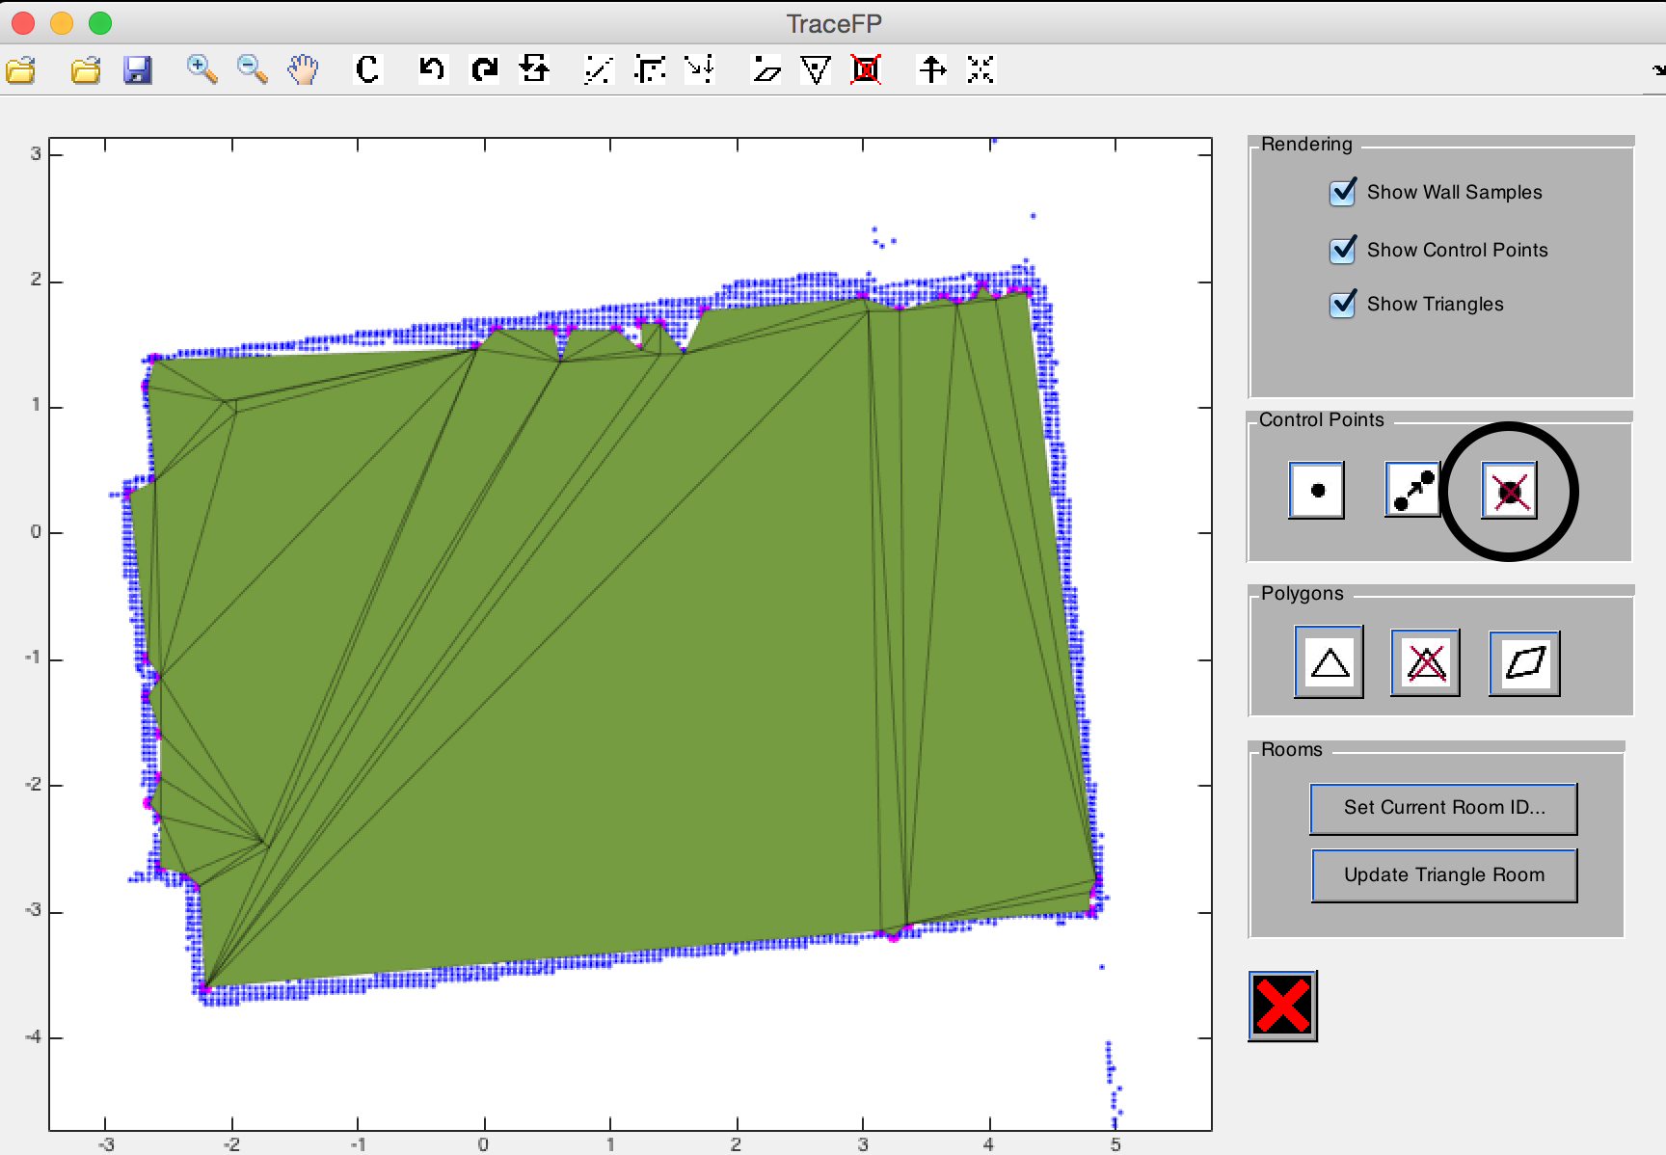



**Basic room manipulation**

**Construct triangle(s) for a room**

To construct a new triangle for the current working room, click the “construct triangle” button (as indicated below), and then click and drag to select three points for constructing the triangle.

User can right click anywhere on floor plan to exit this functionality anytime.

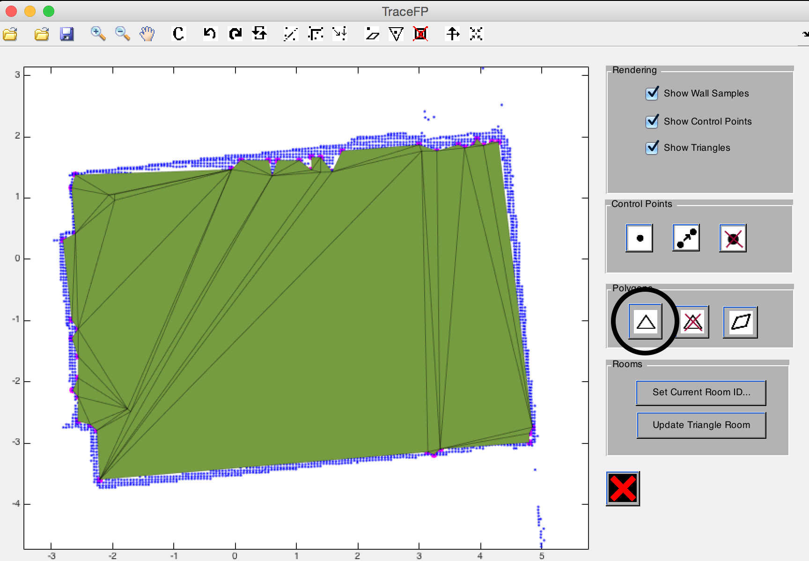

**Remove triangle(s) from a room**

To remove triangles from the current floor plan, click the “remove triangle” button (as indicated below), and then click on all the triangles they would like to remove. User can right click anywhere on floor plan to exit this functionality anytime.

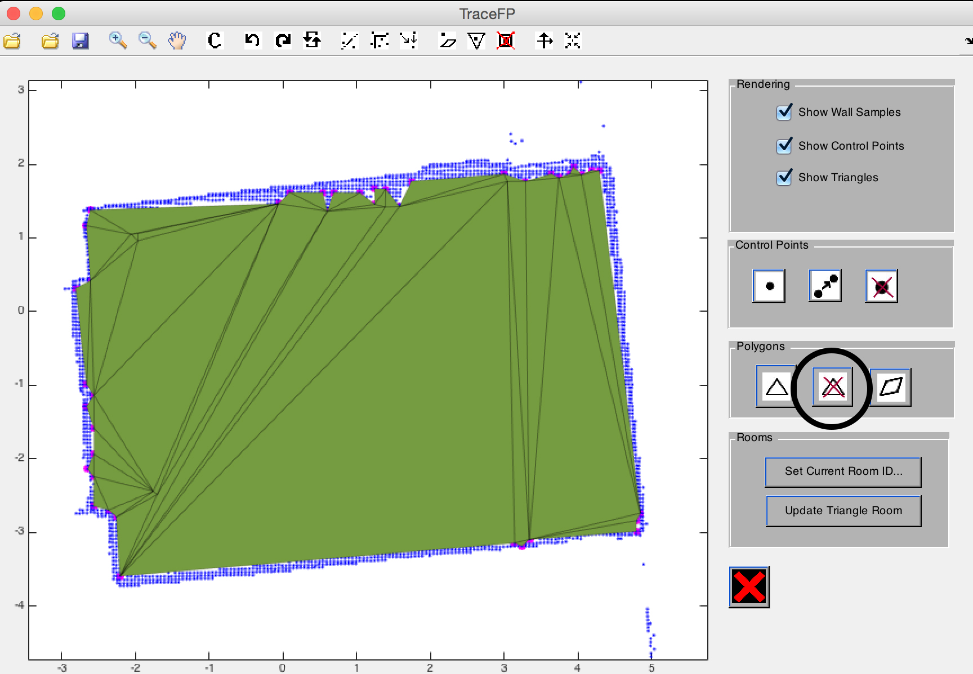

**Construct convex polygon(s) for a room**

To construct a new triangle for the current working room, click the “construct triangle” button (as indicated below), and then click and drag to select a set of points. Triangles will be filled among those points without overlapping each other until the space bounded by those points is completely covered by triangles from the current room. User can right click to exit this functionality anytime.

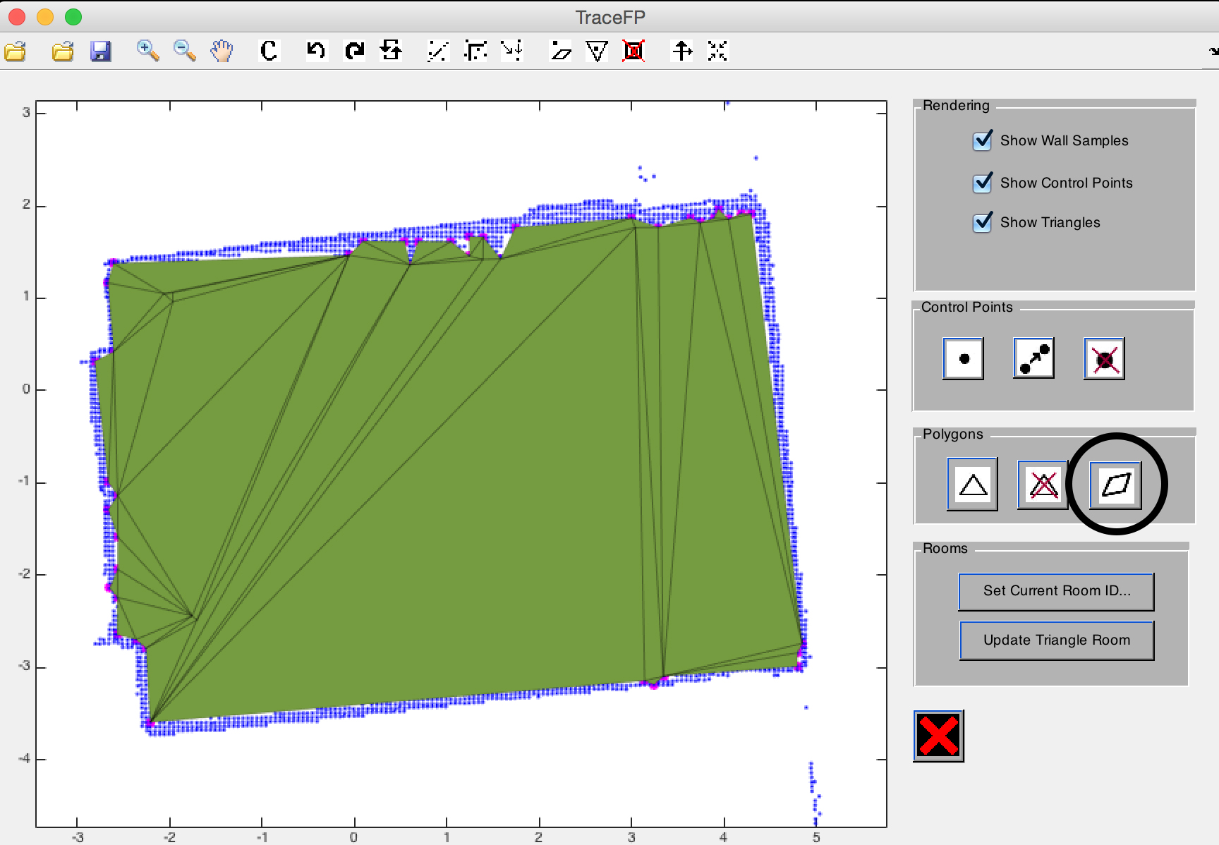

“construct triangle” button will map the points on left to that on the right.

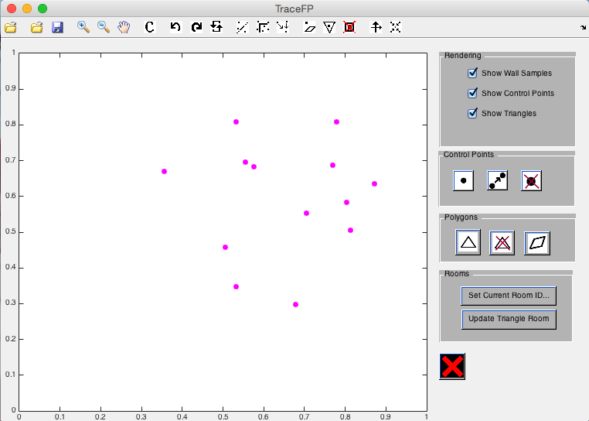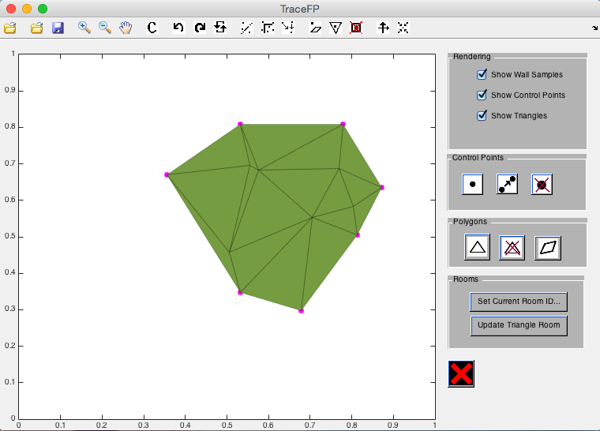

**Undo / Redo**

User can undo or redo their action by clicking the undo / redo buttons (as indicated below).

Redo: button with the leftlefts pointer

Undo: button with the rightwards pointer

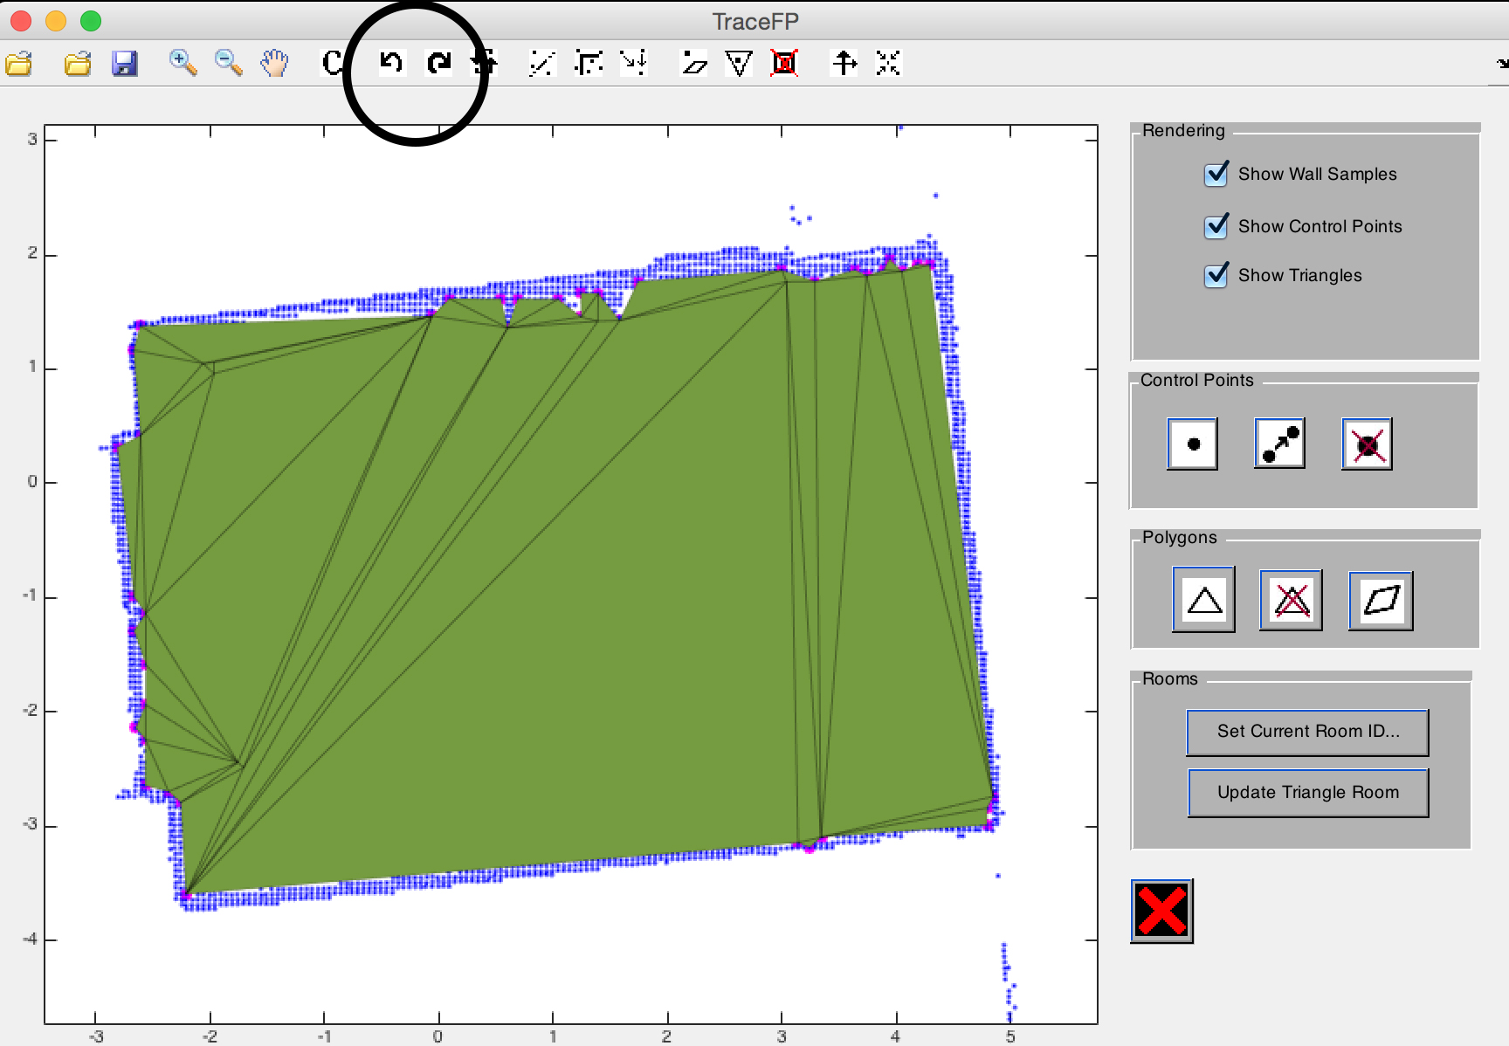

**Advanced floor plan manipulation**

**Points**

**Merge multiple points into one point**

To merge multiple points into one point, user can use the “merge points” button (as indicated below). First, click and drag to select a set of points, then select a final point in second click. All the points selected in the first selection will be merged into the final points.

User can exit this functionality anytime by right clicking on the floor plan.

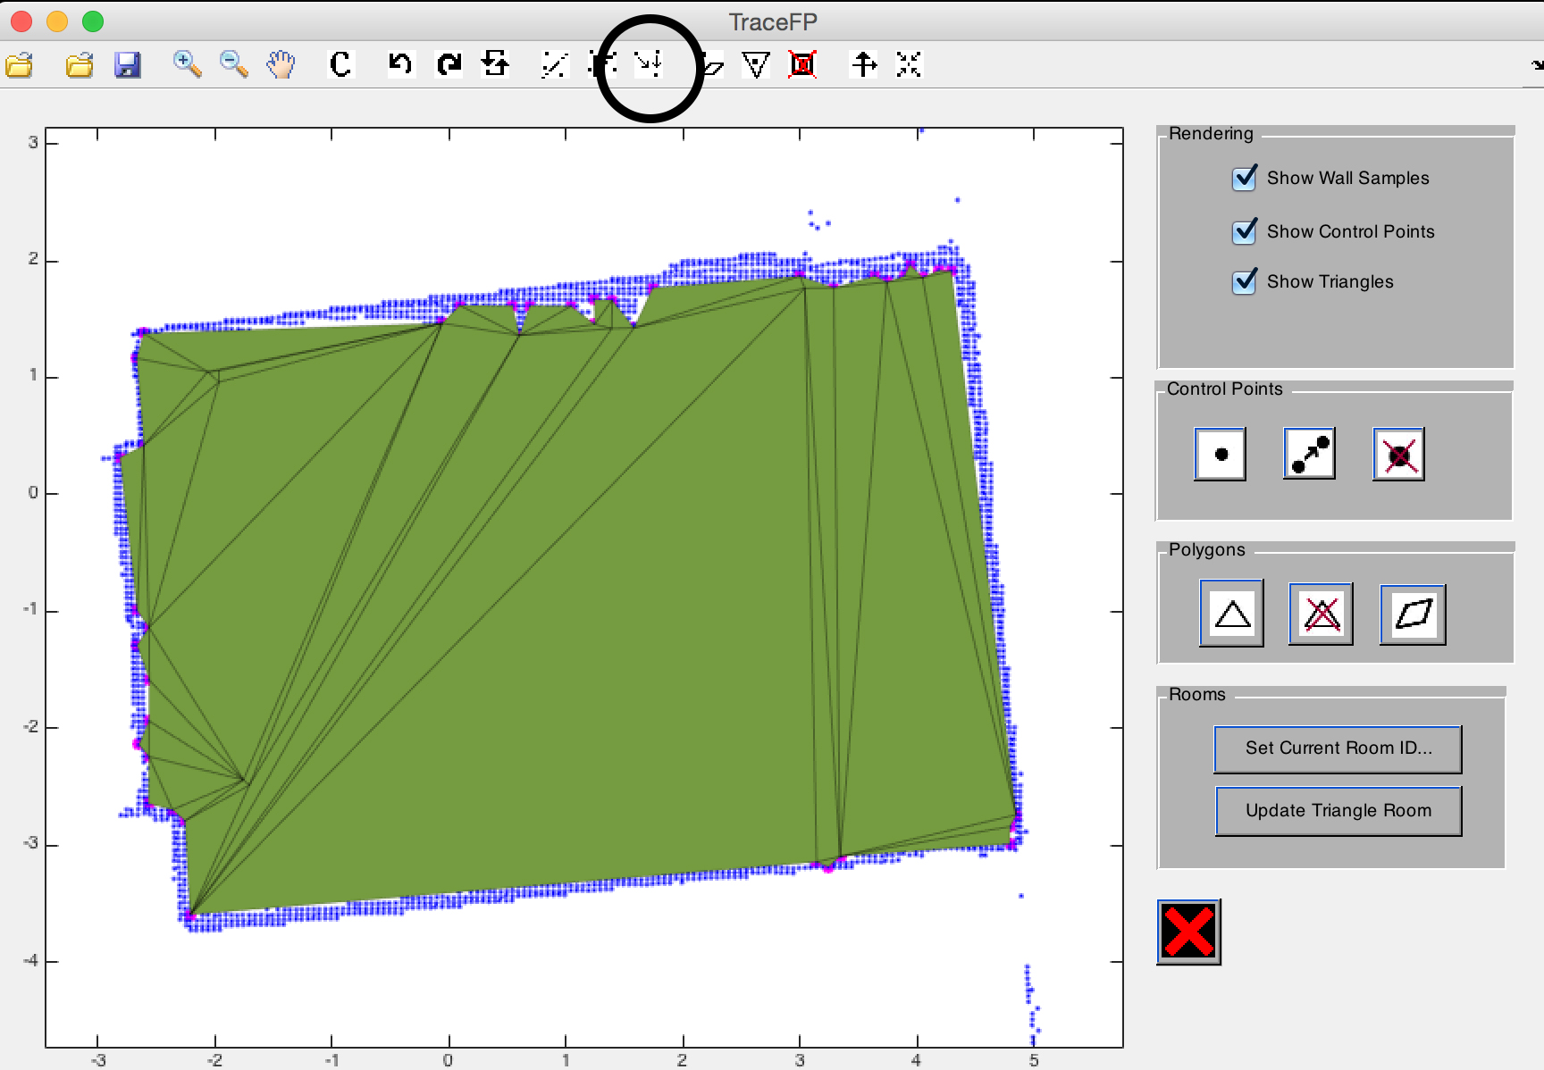

In this example, we will merge all the internal points in the room to the point in the middle of the room.

First, we will select all the internal control points by click and drag.

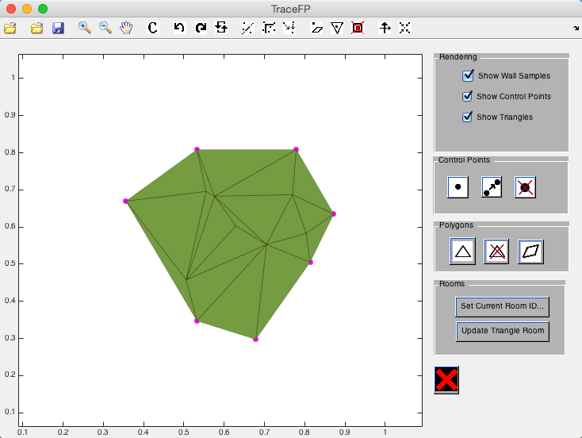

Then, we select the control point in the middle of the room.

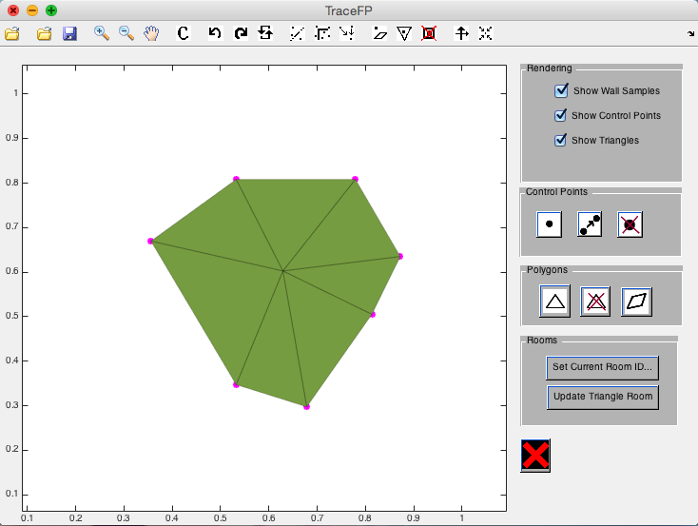

**Clustering points**

To cluster points and merge nearby points, “cluster points” button (as indicated below) can be used. It will automatically try to cluster points into groups and merge each group of points into one, resulting in a simpler floor plan with fewer points, which might be easier to manipulate.

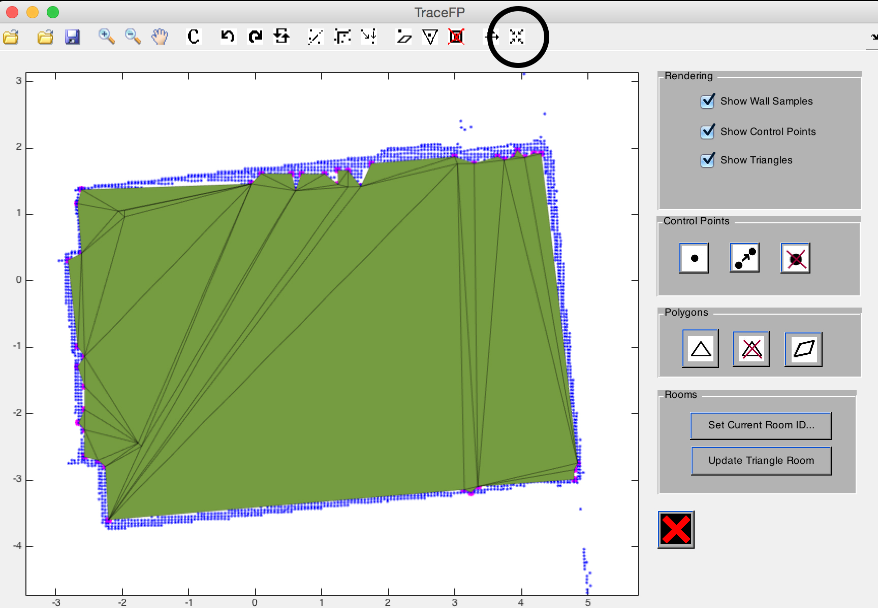In this example, we will use the “cluster points” to simplify a floor plan.

By clicking on “cluster points” button thrice, our floor plan on top is reduced to a simpler one in the bottom.

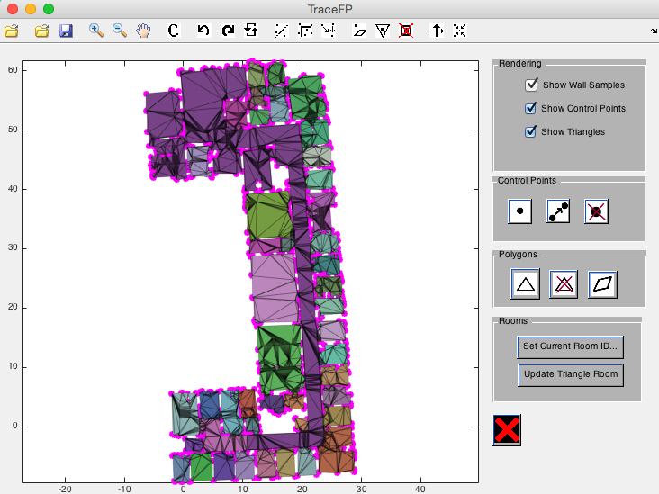

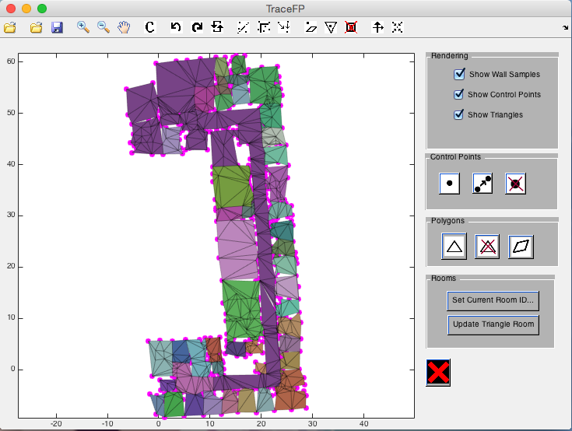

**Lines**

**Align points to a line**

To aligning points to any imaginary line, “align points to line” (as indicated below) button can be used.

User selects any two positions on the floor plan. Then, select a set of points via click and drag. All the points selected through the third selection will be aligned to the line between the two positions selected.

User can exit this functionality anytime by right clicking on the floor plan.

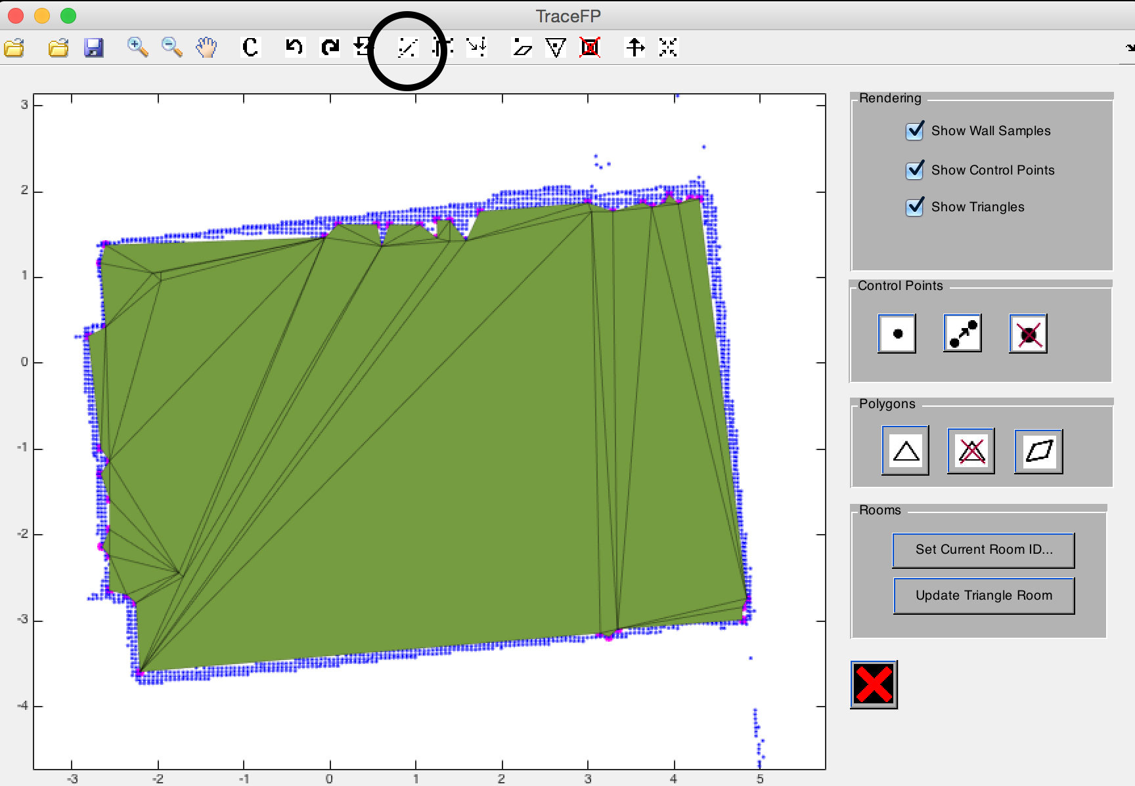In this example, we will use the “align points to line” to align all points at the bottom of the floor plan into a line.

By clicking around the two positions as indicated by the black spots on the first figure, then drag and select all the points in the bottom boundary, we can align all the points there into one straight line.

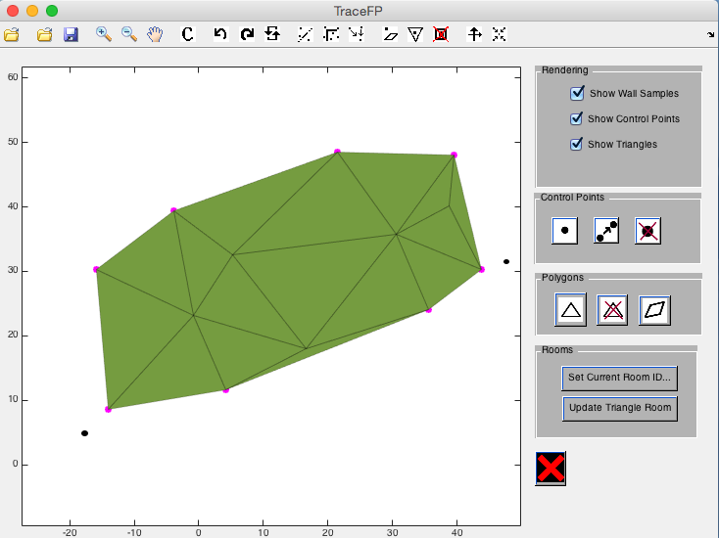

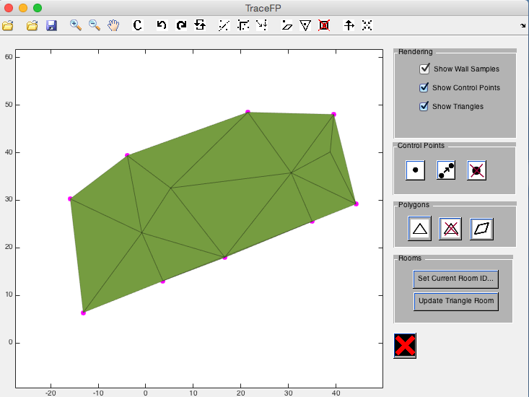

**Align points to a pair of orthogonal lines**

The “align to orthogonal line” button allows the user to align points to two lines, which are orthogonal to each other.

This functionality involves three clicks:

1. Points in the first line

Points selected in this selection will be fit into the line of best fit of these points.

1. The point in the first line which intersects with the orthogonal line

The point selected here determines the orthogonal line going to be used in later parts by extending an imaginary line from this selected point, orthogonal to the first selected line.

1. All the points selected here will be aligned with the orthogonal line

User can exit this functionality anytime by right clicking on the floor plan.

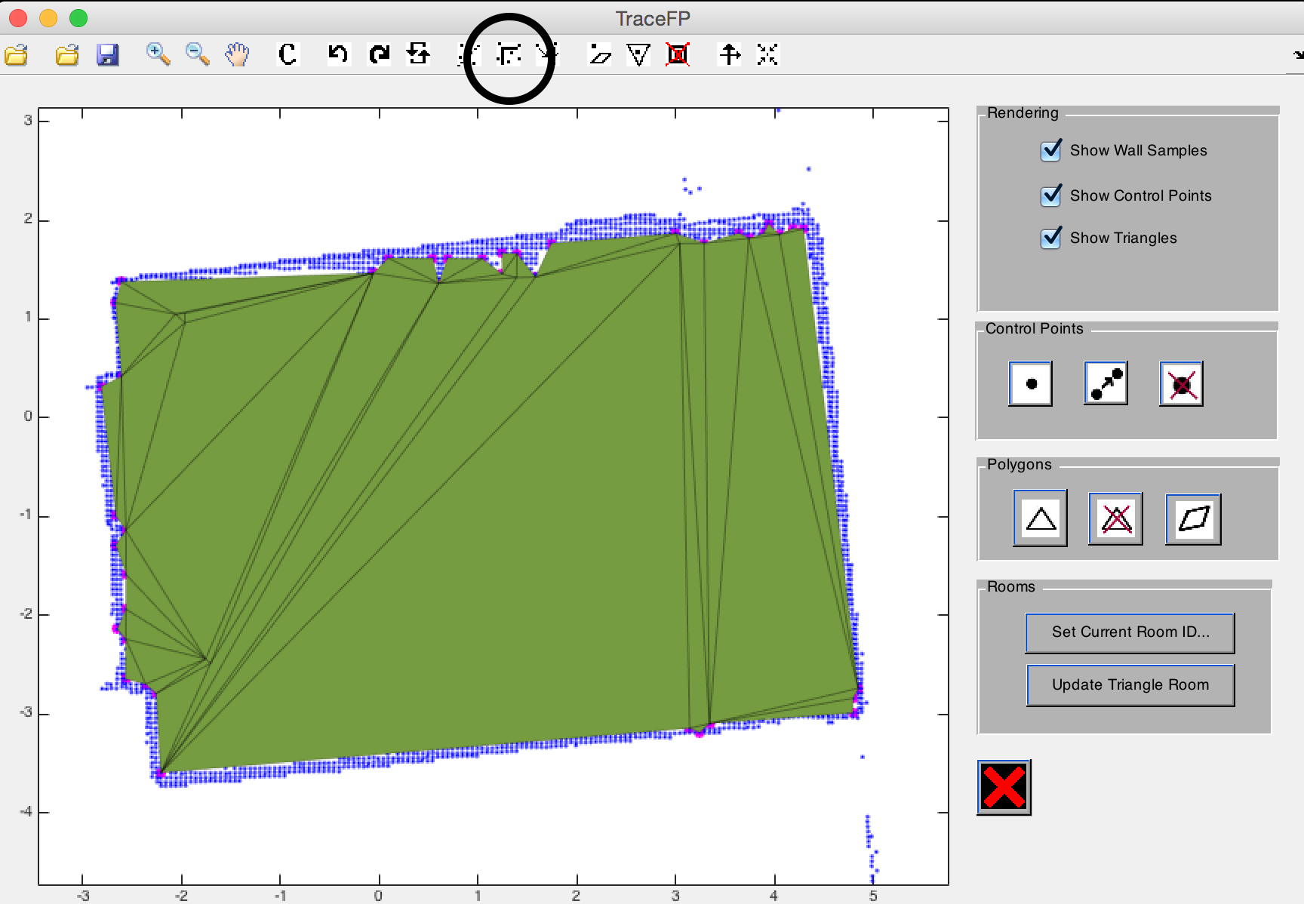In this example, we will use the “align to orthogonal line” to align the points on the bottom right corner into a right angle (90°).

We will do the three selection steps as indicated on the left figures, which results in the floor plan shown on the right figure.

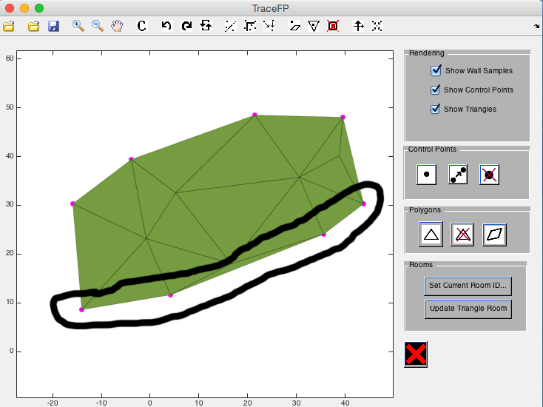

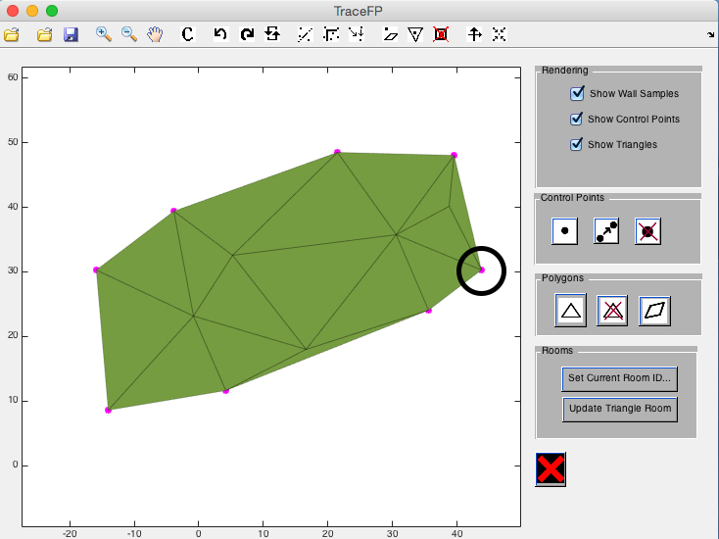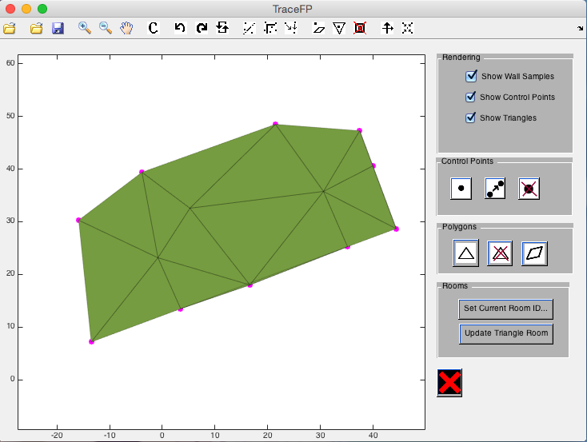

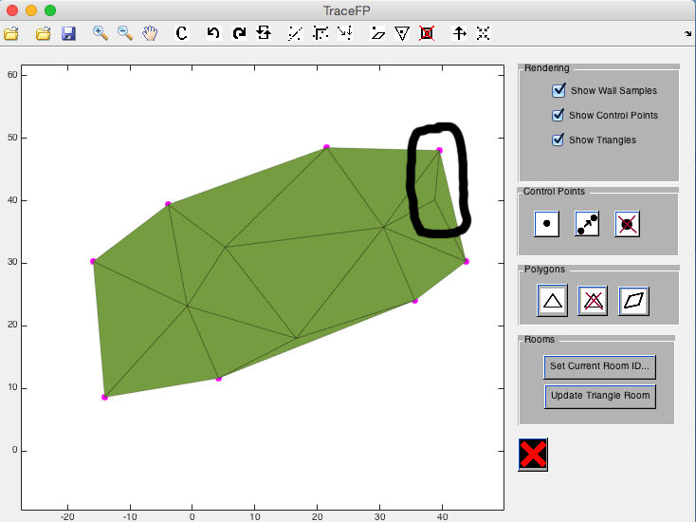

**Rooms**

**Add a point to a room and extend room borders**

The button “add point to existing room” adds a point to an existing room, and construct triangles to cover as much uncovered area as possible.

This functionality requires user to click on the floor plan. Then, all possible non-conflicting triangles among points in the current working room and that point are constructed.

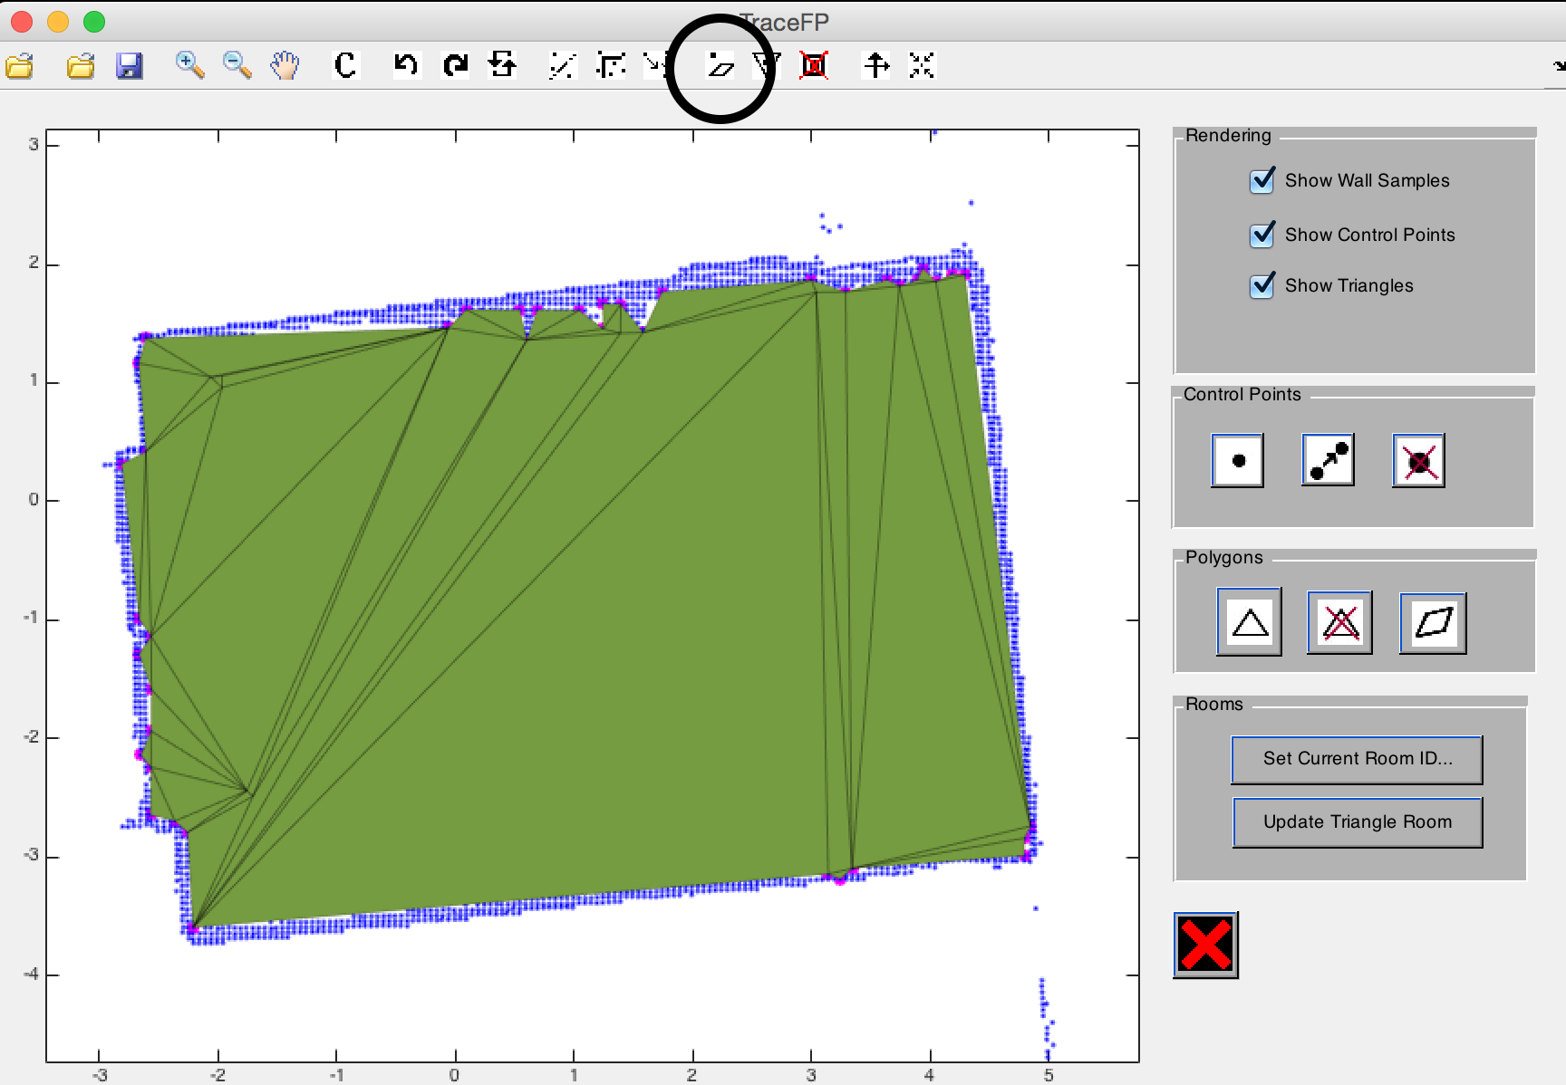This example demonstrates how to add a point to a room easily.

In the top figure is the current room. By using this functionality and clicking on the point in the bottom, we can easily expand the room up to that point (lower figure).

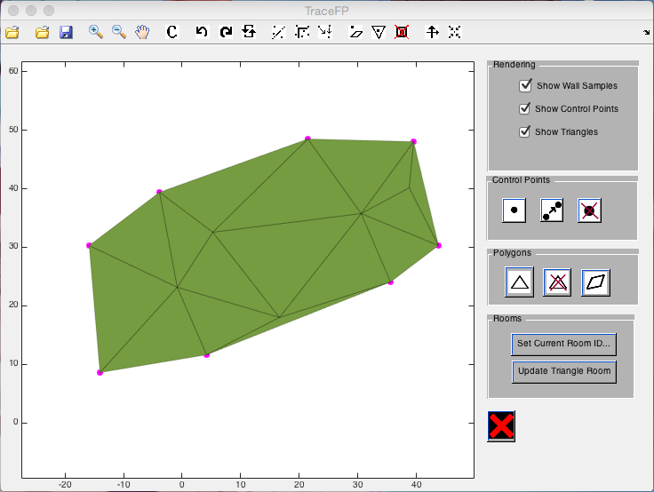

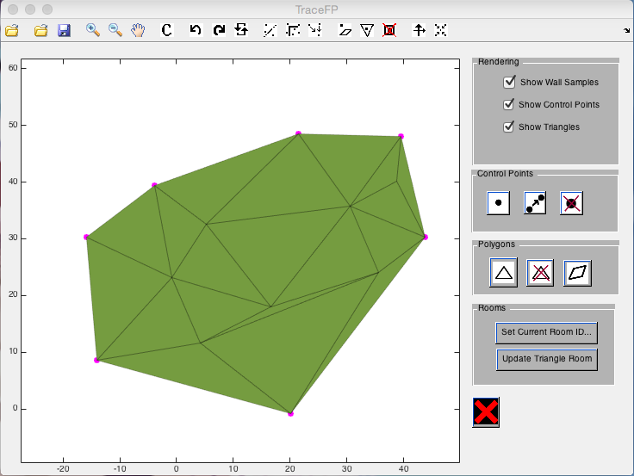

**Split a triangle into multiple triangle along a point**

This functionality splits a triangle along a point, allowing user to do subsequent actions on finer triangles.

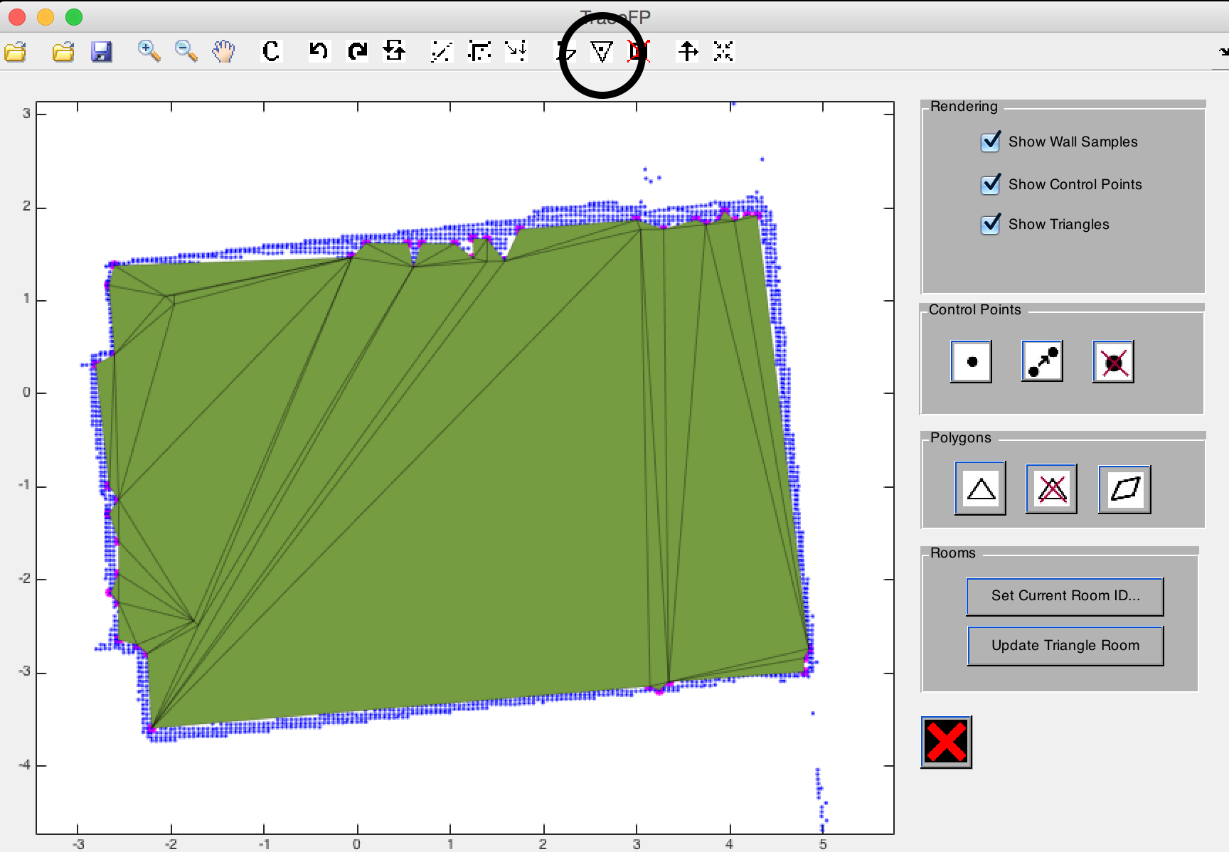This example demonstrates how to use the “split triangle” functionality to split a triangle. The top figure is what we start with. Then, we click on the middle of the triangle, which results in 3 finer triangles.

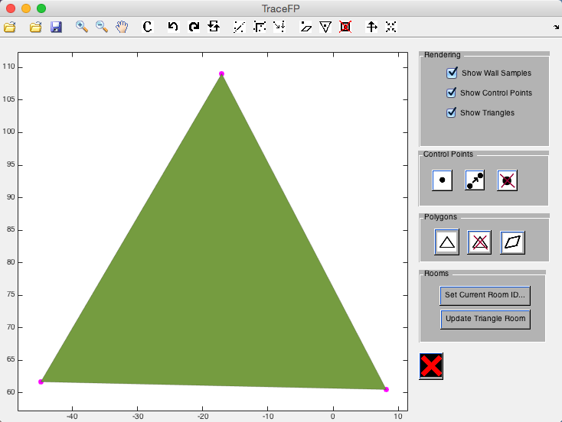

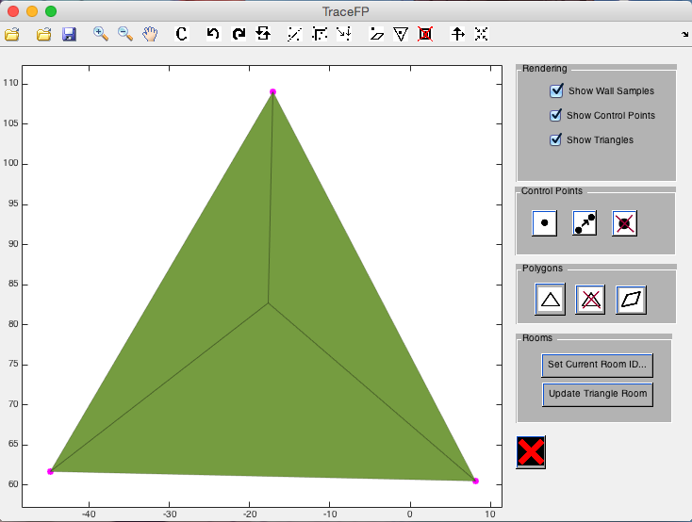

**Reduce number of triangles without changing coverage of the rooms**

This functionality simplifies the floor plan without changing the actual coverage (area covered by each room) of each room. It reorganizes the distribution of triangles in a room so that fewer triangles are needed to cover the same area.

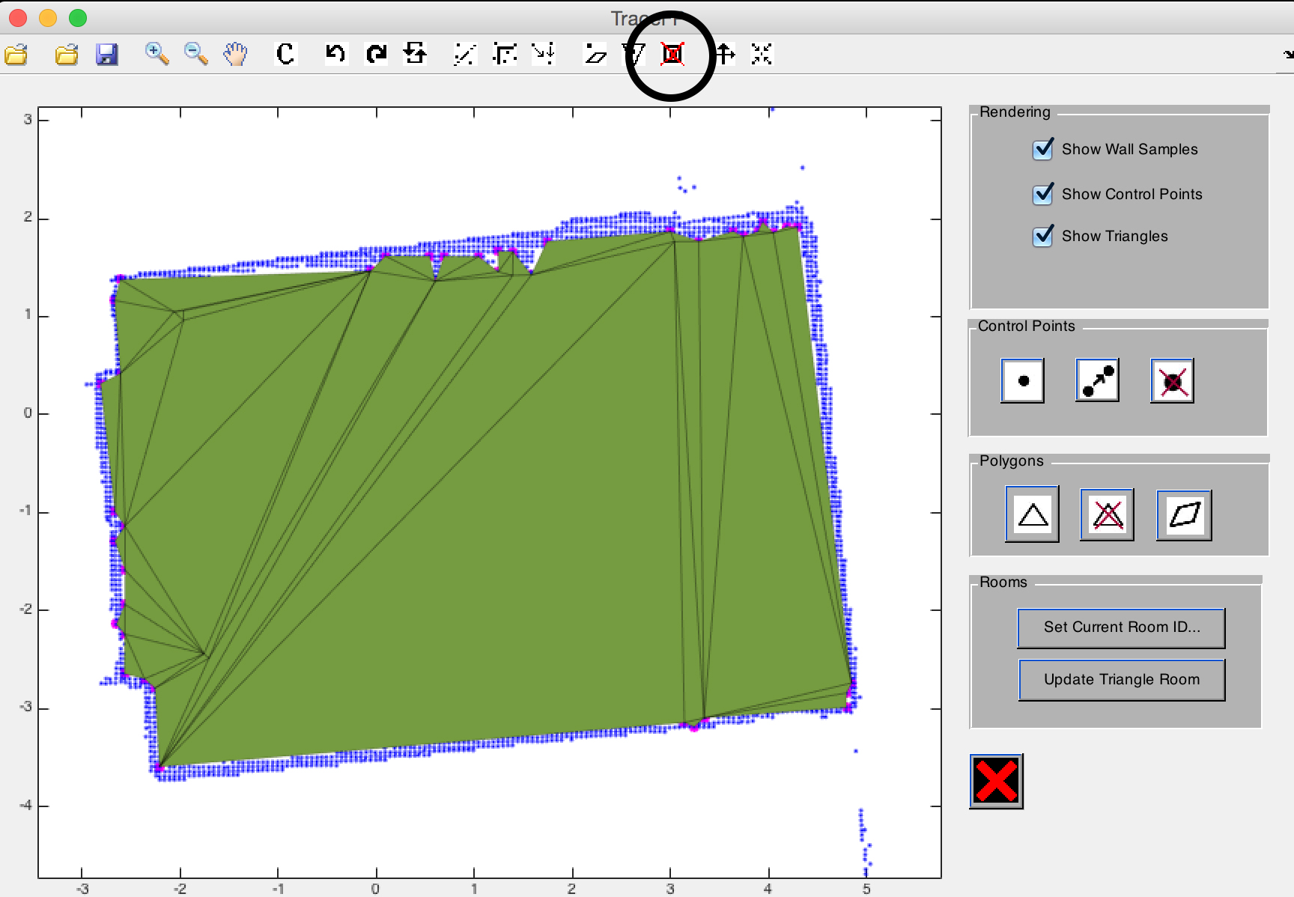The following example demonstrates this functionality. We start with the top figure. Then, we click once on the button, resulting in the bottom figure.

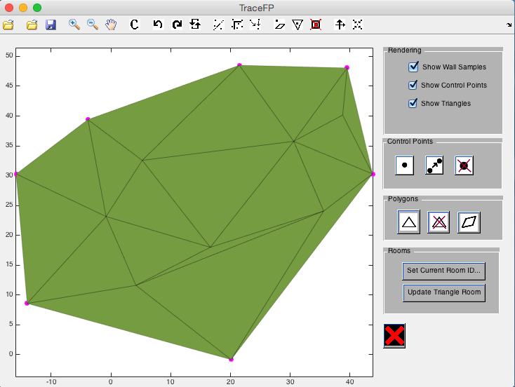

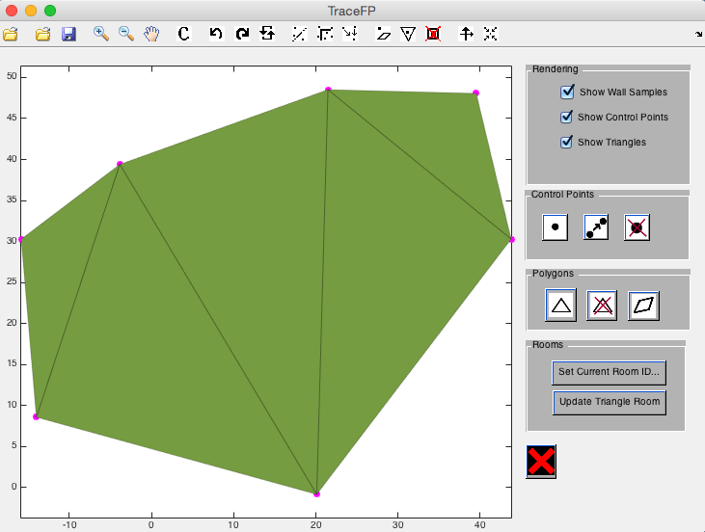

**Axis alignment**

**Align lines on floor plan to specific axis**

This functionality aligns lines “parallel to” a user defined axis to that axis’s orientation. The user will be required to click two positions on the floor plan to indicate an orientation. All lines within “tolerance degree” will be considered “parallel to” that orientation, and will be fixed to that orientation.

Note that opposite orientations are considered the same,

e.g.

vertical upwards and vertically downwards are the same

50° (counterclockwise from x-axis), -130° (counterclockwise from x-axis) are the same as well.

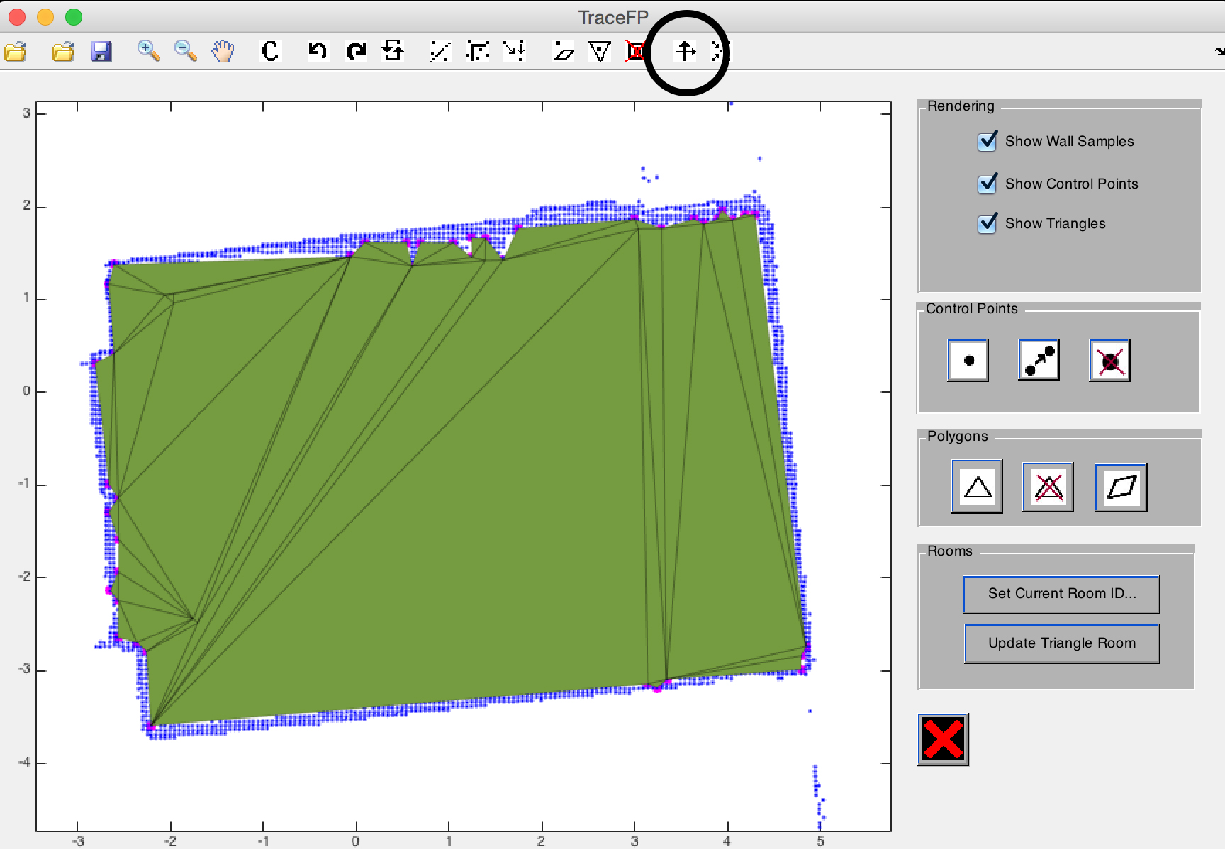This example demonstrates how to use this functionality to align all “horizontal” lines to the “horizontal” axis (the axis at around 15°). We clicked on the two positions as indicated by the black spots on the top figure. All the lines, no matter they are at the top half or bottom half of the floor plan, are tilted and moved so that they can fit to the orientation while not affecting the overall arrangement of the floorplan.

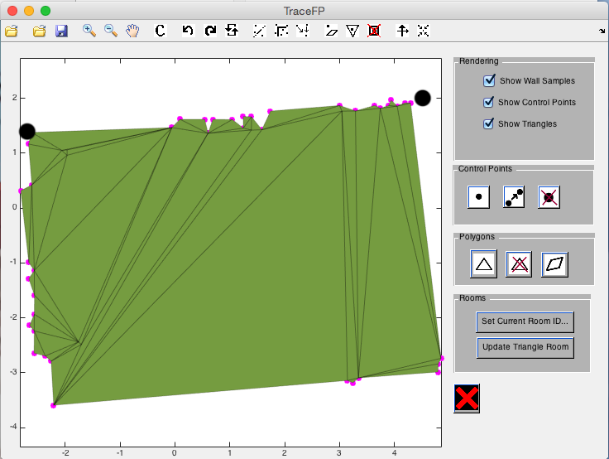

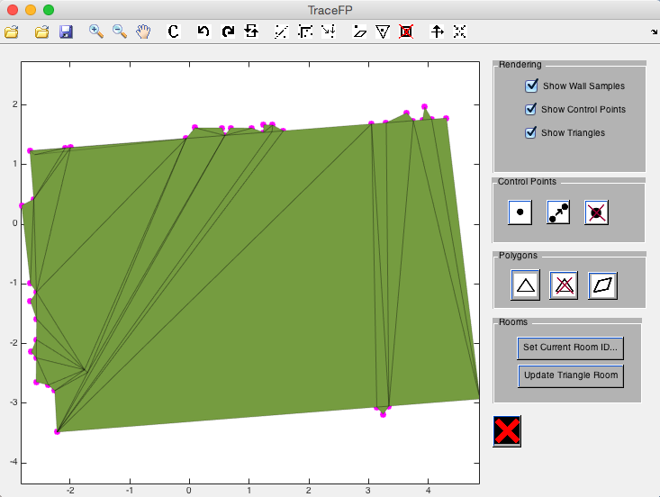**Adjusting tolerance degree**

The tolerance degree for being considered as “parallel” can also adjusted through the “constants” button (as indicated in the top figure). After clicking the button, a window showing the current value of the tolerance degree value will appear, and prompt user for a new tolerance. (as indicated in the bottom figure)

